|  |
| --- |
| **Concordia University**  **Department of Computer Science**  **and Software Engineering** |

|  |
| --- |
| **Touch For Food** |

|  |
| --- |
| **User Manual** |

|  |
| --- |
| **SOEN 490**  **Capstone Project**  **Fall 2012 – Winter 2013** |

|  |  |
| --- | --- |
| **CloudNine** |  |
| Josh Hum (Team Leader) | 9583157 |
| Katrina Anderson | 9106251 |
| Cristian Asenjo | 9280014 |
| Christian Daher | 9599673 |
| Cynthia Donato | 9353852 |
| Mikhail Levkovsky | 9583165 |
| Patrick Modafferi | 9401377 |
| Ryan Nasr | 9605614 |
| Matthew Tam | 9675701 |

**Table of Contents**

1 Introduction 8

2 Using TFF as a Customer 8

2.1 Acquiring a Table 8

2.2 Creating a New Account (Requires 2.1) 12

2.3 Viewing Menus (Requires 2.1) 13

2.4 Viewing an Item’s Description (Requires 2.3) 15

2.5 Adding an Item (and optional side) to a User’s Order (Requires 2.3) 16

2.6 Viewing Suggested Menu Items (Requires 2.3) 18

2.7 Viewing Most Ordered Items (Requires 2.3) 19

2.8 Viewing Top Rated Items (Requires 2.3) 20

2.9 Searching for Items (Requires 2.1) 21

2.10 Creating a Service Request (Requires 2.1) 23

2.11 Managing an Order (Requires 2.5 to be completed at least once) 25

2.12 Removing an Item from an Order (Requires 2.11) 26

2.13 Canceling an Order (Requires 2.11) 28

2.14 Finalizing an Order (Requires 2.11) 30

2.15 Viewing an Order’s Status (Requires 2.14) 31

2.16 Managing a Bill (Requires 2.14) 34

2.17 Creating a Bill (Requires 2.16) 36

2.18 Adding Items to a Bill (Requires 2.17) 37

2.19 Removing an Item from a Bill (Requires 2.18) 38

2.20 Viewing User Profile (Requires 2.1) 39

2.21 Editing a User Profile (Requires 2.20) 40

2.22 Viewing Past Orders (Requires 2.18 as well as having paid for it) 41

2.23 Leaving a Review (Requires 2.22) 42

2.24 Viewing Past Reviews (Requires 2.23) 44

3 Using TFF as a Restaurant 45

3.1 Logging In to TFF 45

3.2 Creating a New Menu (Requires 3.1) 46

3.3 Activating/Deactivating a Menu (Requires 3.2) 48

3.4 Removing a Menu (Requires 3.2) 49

3.5 Creating a Menu Category (Requires 3.2) 50

3.6 Adding a Menu Category (Requires 3.5) 51

3.7 Removing a Menu Category (Requires 3.6) 52

3.8 Creating Menu Items (Requires 3.5) 53

3.9 Adding Menu Items to a Menu Category (Requires 3.8) 55

3.10 Removing Menu Items from a Category (Requires 3.9) 56

3.11 Creating a Menu Side (Requires 3.5) 57

3.12 Adding a Menu Side (Requires 3.11) 58

3.13 Removing a Menu Side (Requires 3.12) 59

3.14 Creating Tables (Requires 3.1) 60

3.15 Editing a Table (Requires 3.14) 61

3.16 Viewing a Table’s Details (Requires 3.14) 62

3.17 Removing a Table (Requires 3.14) 63

3.18 Managing Orders (Requires 2.5, 3.9, 3.14) 64

3.19 Managing Service Requests (Requires 2.10 and 3.14) 67

3.20 Managing a Table’s Bills (Requires 3.18) 70

3.21 Creating a Bill (Requires 3.20) 71

3.22 Adding Items to a Bill (Requires 3.21) 72

3.23 Removing an Item from a Bill (Requires 3.22) 73

3.24 Viewing Report for Most Popular Dish (Requires 2.14 at least once) 74

3.25 Viewing Waiter Statistics Report (Requires 2.10 at least once) 76

Appendix A References 77

**Table of Figures**

Figure 2‑1 Opening of TFF Mobile App from Home Screen 8

Figure 2‑2 Scanning a Table's QR Code 9

Figure 2‑3 Logging In to TFF 10

Figure 2‑4 User Logged in to TFF 11

Figure 2‑5 Creating an Account 12

Figure 2‑6 Viewing the List of Menus 13

Figure 2‑7 Viewing a Menu 14

Figure 2‑8 Viewing an Item's Description 15

Figure 2‑9 Picking a Side for a Selected Menu Item 16

Figure 2‑10 A Menu Item Added Successfully 17

Figure 2‑11 Viewing Suggested Menu Items 18

Figure 2‑12 Viewing Most Ordered Items 19

Figure 2‑13 Viewing Top Rated Items 20

Figure 2‑14 Searching for Keyword "Nachos" 21

Figure 2‑15 Viewing Search Results for "Nachos" 22

Figure 2‑16 Call Waiter Page 23

Figure 2‑17 After the Service Request was Submitted 24

Figure 2‑18 Managing an Order 25

Figure 2‑19 Order with Item to be Removed 26

Figure 2‑20 Order after Item was Removed 27

Figure 2‑21 Order to be Canceled 28

Figure 2‑22 After Canceling Order 29

Figure 2‑23 Order After the Finalize Button was Tapped 30

Figure 2‑24 Viewing an Order's Status after Finalizing It 31

Figure 2‑25 Viewing an Order's Status after it was Accepted 32

Figure 2‑26 Viewing an Order's Status after it was Delivered 33

Figure 2‑27 Viewing an Accepted Order 34

Figure 2‑28 Manage Bills Page 35

Figure 2‑29 Creating a New Bill Figure 2‑30 New Bill Created 36

Figure 2‑31 Item Added to a Bill 37

Figure 2‑32 Bill Before Removing Item Figure 2‑33 Bill After Removing Item 38

Figure 2‑34 Viewing a Profile after tapping on the User's Name 39

Figure 2‑35 Editing a User Profile 40

Figure 2‑36 Viewing Past Orders 41

Figure 2‑37 Picking Past Order to Review 42

Figure 2‑38 Creating a Review 43

Figure 2‑39 Viewing Past Reviews 44

Figure 3‑1 Home Page 45

Figure 3‑2 Login Page 45

Figure 3‑3 Home Page 46

Figure 3‑4 Menus Page 46

Figure 3‑5 Creating a New Menu 47

Figure 3‑6 Newly Created Menu 47

Figure 3‑7 Supper Menu Activated 48

Figure 3‑8 Deleting a Menu 49

Figure 3‑9 Creating a New Category 50

Figure 3‑10 New Category Created 50

Figure 3‑11 Before Adding a Category 51

Figure 3‑12 After Adding a Category 51

Figure 3‑13 Removing a Category 52

Figure 3‑14 Viewing a Menu Category 53

Figure 3‑15 Creating a New Item 53

Figure 3‑16 New Menu Item Added 54

Figure 3‑17 Viewing a Menu Category 55

Figure 3‑18 After Pressing the Add Item Button 55

Figure 3‑19 Deleting a Menu Item 56

Figure 3‑20 Creating a New Side 57

Figure 3‑21 New Side Successfully Added 57

Figure 3‑22 Before Adding a Side 58

Figure 3‑23 After Adding a Side 58

Figure 3‑24 Removing a Menu Side 59

Figure 3‑25 Viewing List of Tables 60

Figure 3‑26 Creating a New Table 60

Figure 3‑27 Editing a Table 61

Figure 3‑28 Viewing a Table's Details 62

Figure 3‑29 Deleting a Table 63

Figure 3‑30 Manage Orders Page 64

Figure 3‑31 Canceling an Order 64

Figure 3‑32 Declining an Item 65

Figure 3‑33 Accepted an Item (still undelivered) 65

Figure 3‑34 Delivered Item 66

Figure 3‑35 Viewing Service Requests 67

Figure 3‑36 Completing a Service Request 67

Figure 3‑37 Cancelling a Request 68

Figure 3‑38 Viewing a Service Request's Details 68

Figure 3‑39 Editing a Service Request 69

Figure 3‑40 Creating a New Service Request 69

Figure 3‑41 Viewing a Table's Orders 70

Figure 3‑42 Managing a Table's Bills 70

Figure 3‑43 Creating a Bill 71

Figure 3‑44 New Bill Created 71

Figure 3‑45 Item Added to a Bill 72

Figure 3‑46 Before Removing Item 73

Figure 3‑47 After Removing Item 73

Figure 3‑48 Reports Menu 74

Figure 3‑49 Creating the Report 74

Figure 3‑50 Viewing Most Popular Dishes Report 75

Figure 3‑51 Creating the Waiter Statistics Report 76

Figure 3‑52 Viewing the Waiter Statistics Report 76

|  |
| --- |
| **Touch For Food** |

|  |
| --- |
| **User Manual** |

|  |
| --- |
| **Version 11.3** |

**Revision History**

|  |  |  |  |
| --- | --- | --- | --- |
| **Date** | **Rev.** | **Description** | **Author(s)** |
| 2013-03-30 | 11.1 | Document Creation | Cristian Asenjo |
| 2013-03-31 | 11.2 | Added restaurant guide | Cristian Asenjo |
| 2013-04-01 | 11.3 | Reviewed user manual and made minor changes | Josh Hum |

# Introduction

This document is the reference for the use of the Touch For Food Application (TFF). The information within this document explains how to use TFF both as a customer and as a restaurant.

# Using TFF as a Customer

The following steps illustrate how to use the various features of TFF when it is being used as a customer.

## Acquiring a Table

1. When the user sits at a table he/she should open the TFF app by tapping on the icon.

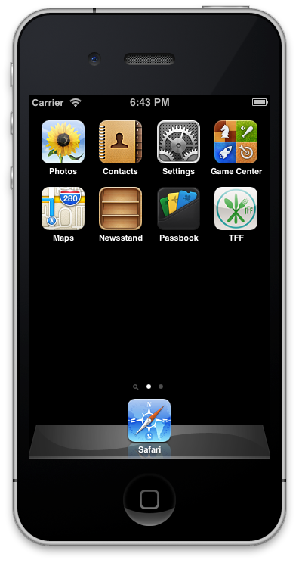

Figure 2‑1 Opening of TFF Mobile App from Home Screen

1. The user will then scan the QR code (or tap the NFC tag) attached to the table.

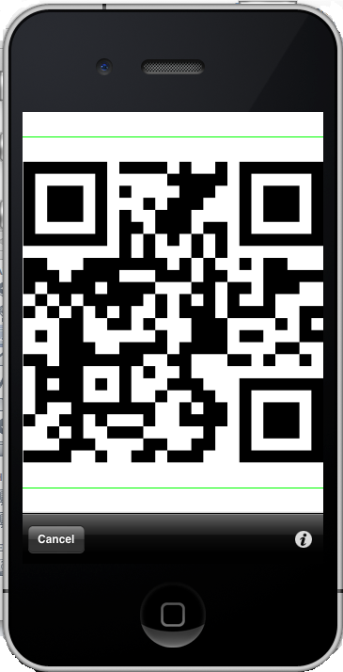

Figure 2‑2 Scanning a Table's QR Code

1. The user will then need to log in to TFF or create a new account (see 2.2).

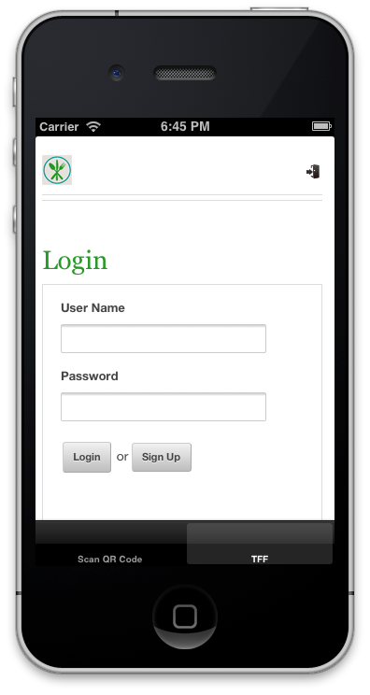

Figure 2‑3 Logging In to TFF

1. Once logged in, the table will automatically be assigned to the user.

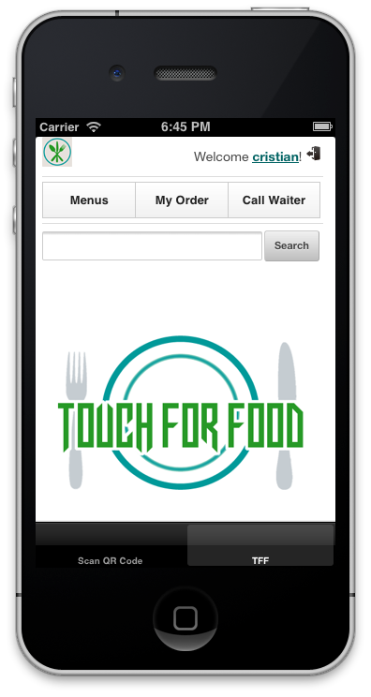

Figure 2‑4 User Logged in to TFF

## Creating a New Account (Requires 2.1)

1. At the login screen, tap on the Sign Up button. Fill out the form and press the Create button to create the account.

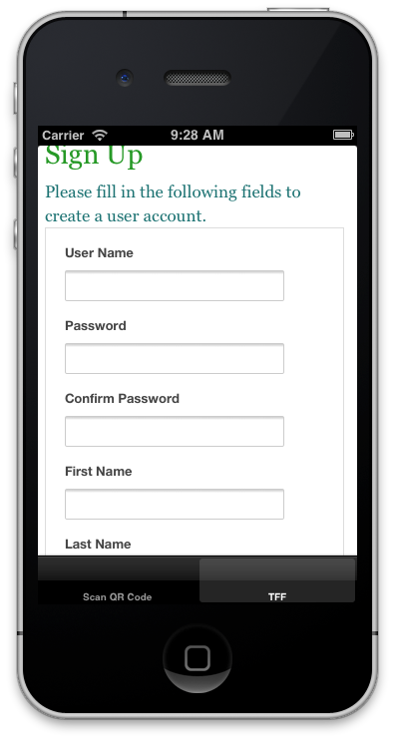

Figure 2‑5 Creating an Account

## Viewing Menus (Requires 2.1)

1. To view a menu the user must tap on the Menus button. This will take the user to the list of menus.

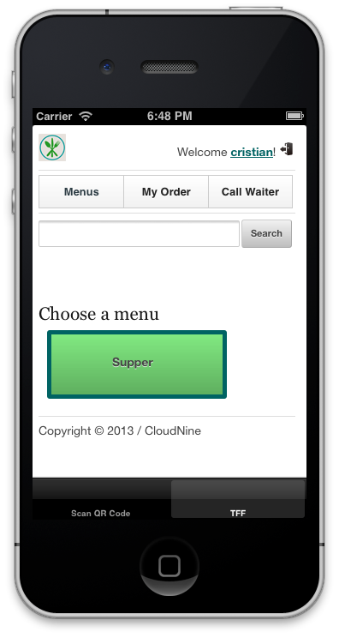

Figure 2‑6 Viewing the List of Menus

1. The user will then tap on the desired menu to view its contents and possible choices like suggested items (2.5), most ordered items (2.6) and top rated items (2.7).

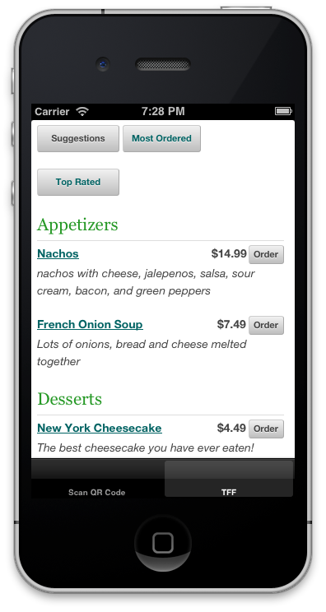

Figure 2‑7 Viewing a Menu

## Viewing an Item’s Description (Requires 2.3)

1. Once a menu has loaded the user may tap on the name of any menu item to view a description and its past reviews. The user then must tap on the X button in the pop-up in order to return to the menu items list.

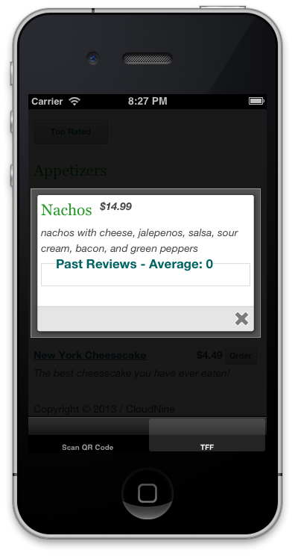

Figure 2‑8 Viewing an Item's Description

## Adding an Item (and optional side) to a User’s Order (Requires 2.3)

1. Once a menu has loaded the user can tap on the Order button to begin adding the item to his/her order. If available, and if the user wishes it, the user may add a side to the order. Once the choices have been made the user presses the Place Order button to add the item to the order.

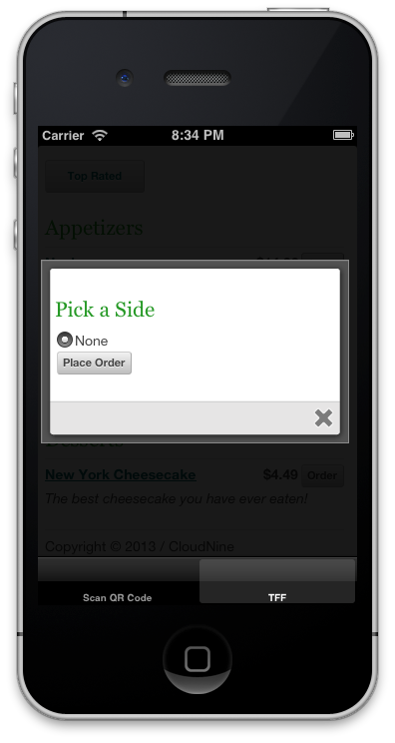

Figure 2‑9 Picking a Side for a Selected Menu Item

1. When the item is added to the order successfully it will be temporarily highlighted in green before it fades back to white.

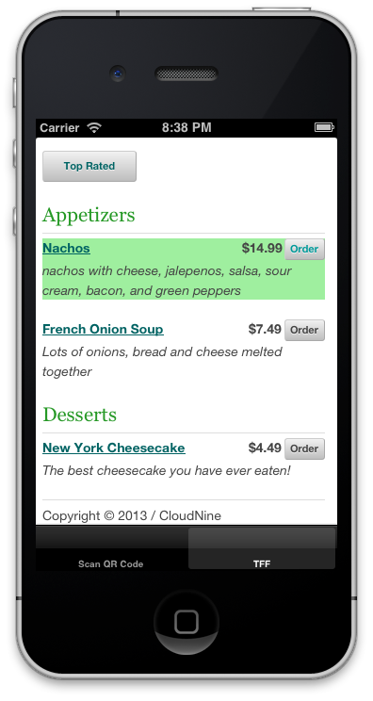

Figure 2‑10 A Menu Item Added Successfully

## Viewing Suggested Menu Items (Requires 2.3)

1. To view suggested menu items a user only has to tap on the Suggestions button and suggested items based on previous orders will be displayed. The user may then add items as described in 2.4.

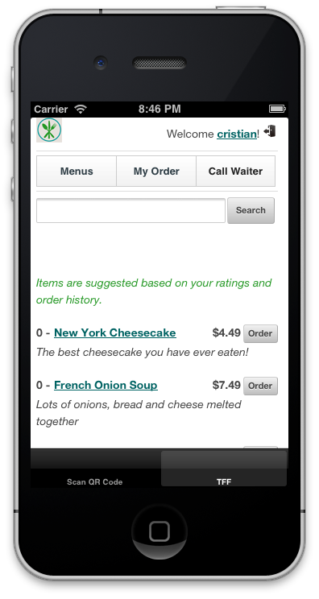

Figure 2‑11 Viewing Suggested Menu Items

## Viewing Most Ordered Items (Requires 2.3)

1. To view the most ordered items a user only has to tap on the Most Ordered button and the most ordered items will be displayed. The user may then add items as described in 2.4.

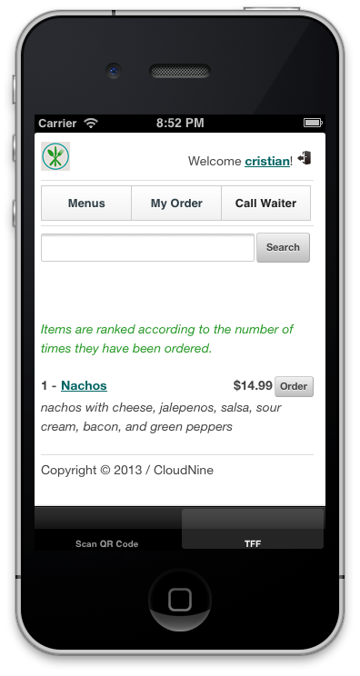

Figure 2‑12 Viewing Most Ordered Items

## Viewing Top Rated Items (Requires 2.3)

1. To view the top rated menu items a user only has to tap on the Top Rated button and the top rated menu items will be displayed. The user may then add items as described in 2.4.

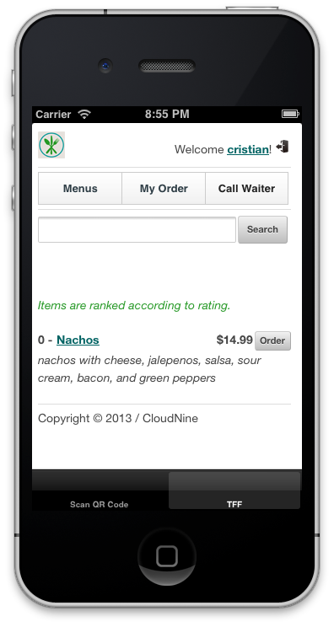

Figure 2‑13 Viewing Top Rated Items

## Searching for Items (Requires 2.1)

1. All menu items are tagged with keywords for easy searching. TFF users have the option of searching for items using the search bar, accessible from any screen. A user must type in a keyword (example: nachos), and then tap on the Search button.

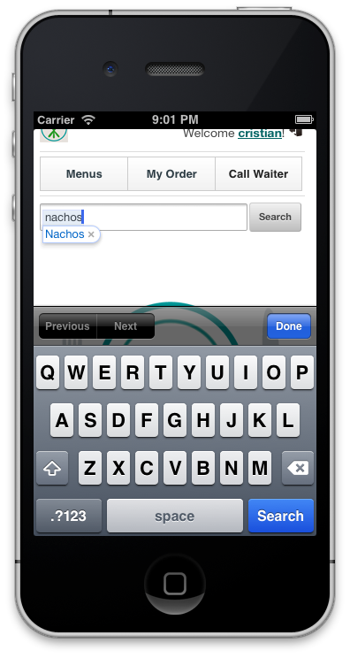

Figure 2‑14 Searching for Keyword "Nachos"

1. The search results (if any) are displayed in the results page, where the user may want to view an item’s description (see 2.3) or add them to the order (see 2.4).

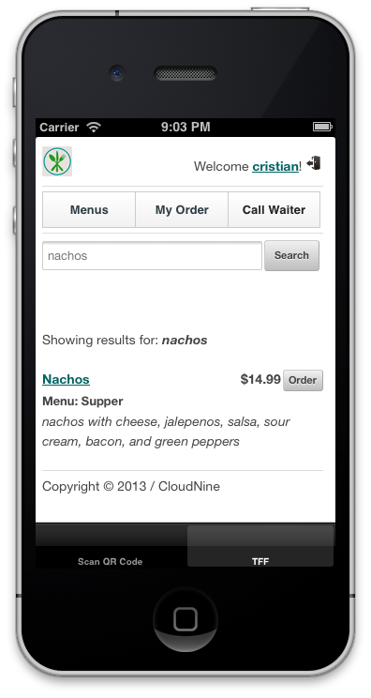

Figure 2‑15 Viewing Search Results for "Nachos"

## Creating a Service Request (Requires 2.1)

1. If a user requires the assistance of a waiter (to ask to pay a bill, for example), it may do so by tapping on the Call Waiter button.

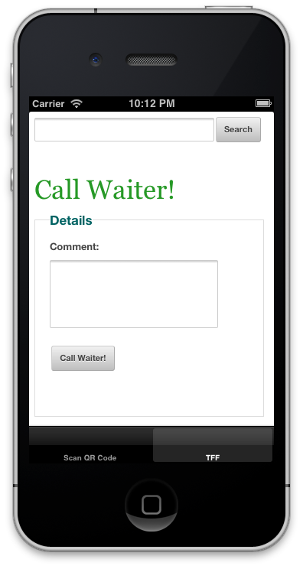

Figure 2‑16 Call Waiter Page

1. The user fills out the comment textbox with the request or question and then taps on the Call Waiter button under the textbox to submit the request.

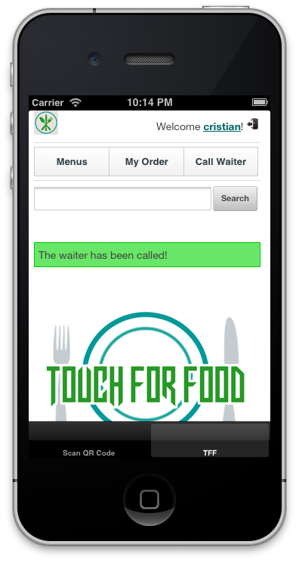

Figure 2‑17 After the Service Request was Submitted

## Managing an Order (Requires 2.5 to be completed at least once)

1. After adding at least one menu item a user may manage his/her order by tapping on the My Order button.

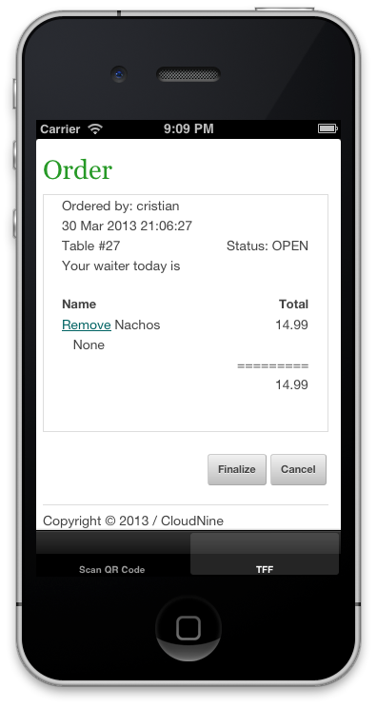

Figure 2‑18 Managing an Order

## Removing an Item from an Order (Requires 2.11)

1. A user can remove an item from his/her order by tapping on the Remove link beside the item.

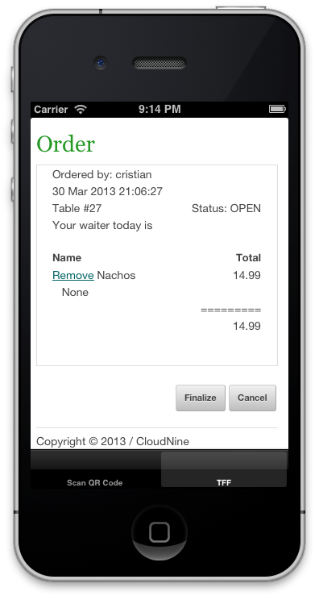

Figure 2‑19 Order with Item to be Removed

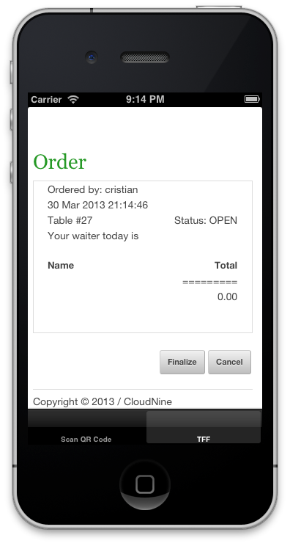

Figure 2‑20 Order after Item was Removed

## Canceling an Order (Requires 2.11)

1. A user may cancel his/her entire order as long as it has not been finalized.



Figure 2‑21 Order to be Canceled

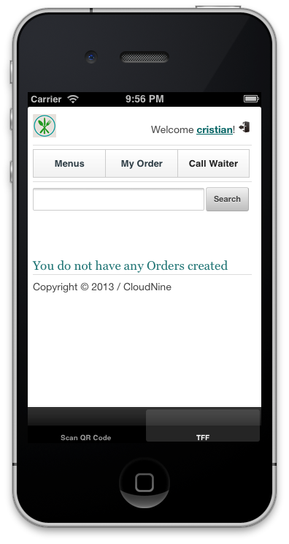

Figure 2‑22 After Canceling Order

## Finalizing an Order (Requires 2.11)

1. Once a user has added all the desired menu items the order must be finalized in order for it to be sent to the restaurant for preparation. The user does this by tapping on the Finalize button.

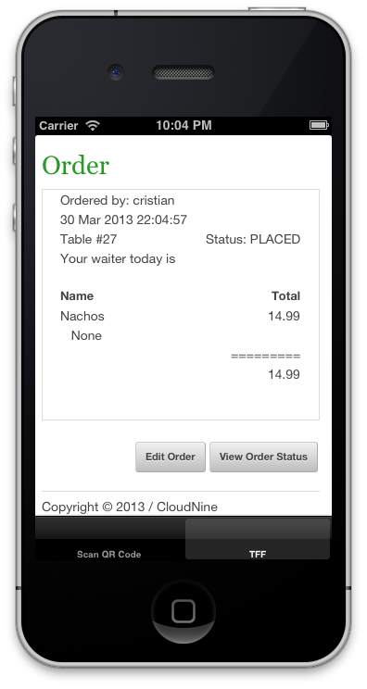

Figure 2‑23 Order After the Finalize Button was Tapped

## Viewing an Order’s Status (Requires 2.14)

1. Once an order has been finalized and sent to the restaurant the user may view its preparation and delivery status. This is done by tapping on the View Order Status button in the My Orders page.

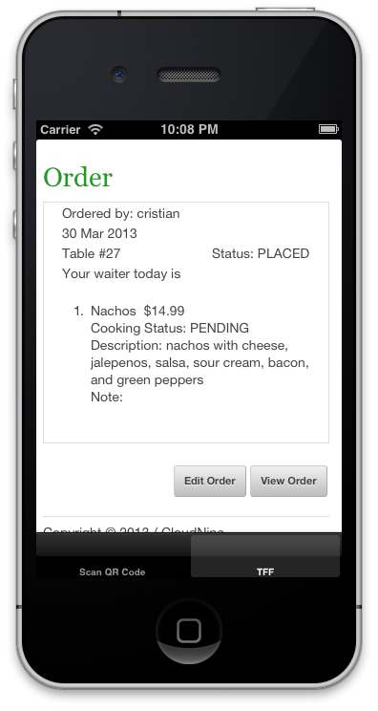

Figure 2‑24 Viewing an Order's Status after Finalizing It

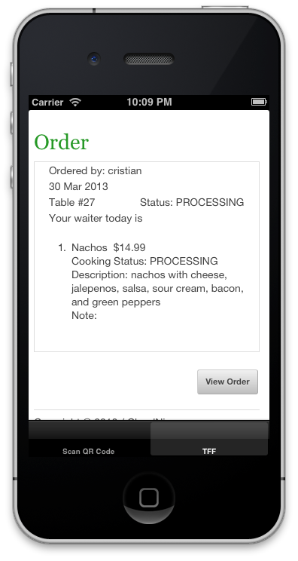

Figure 2‑25 Viewing an Order's Status after it was Accepted

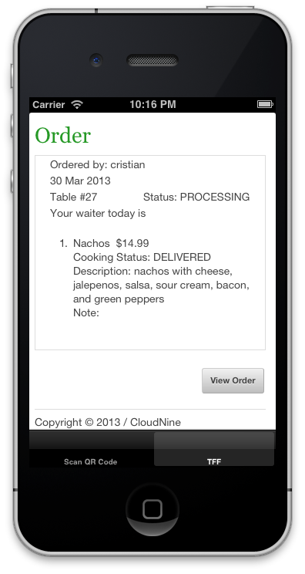

Figure 2‑26 Viewing an Order's Status after it was Delivered

## Managing a Bill (Requires 2.14)

1. Once an order has been accepted by the restaurant the user is allowed to manage the bill by tapping on the Manage Bills button.

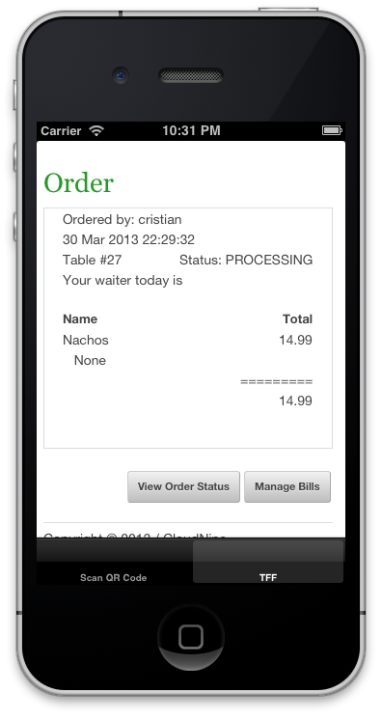

Figure 2‑27 Viewing an Accepted Order

1. When the user taps on the Manage Bills button the Manage Bills page will be displayed.

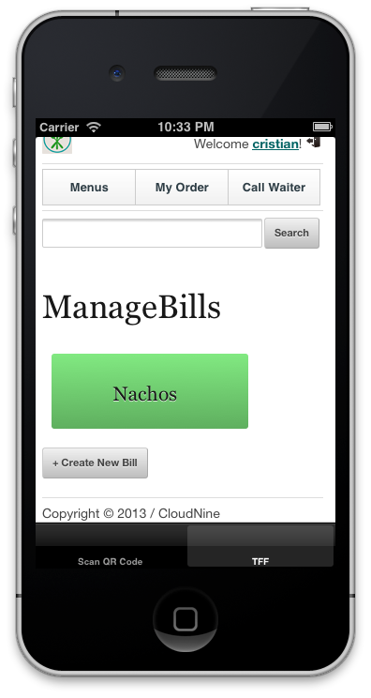

Figure 2‑28 Manage Bills Page

## Creating a Bill (Requires 2.16)

1. The user may create a bill by tapping on the Create New Bill button and then clicking on OK when the question “Are you sure you want to add?” appears.

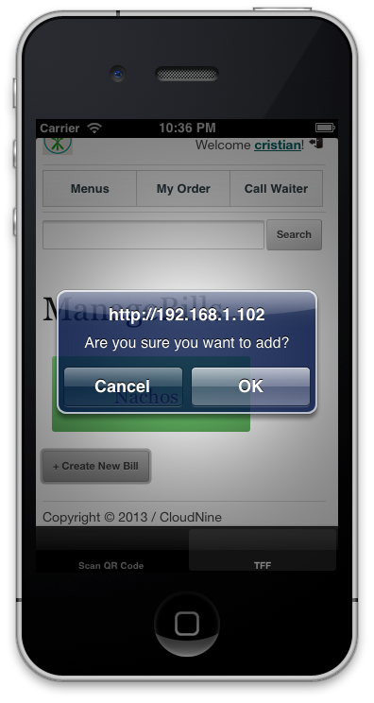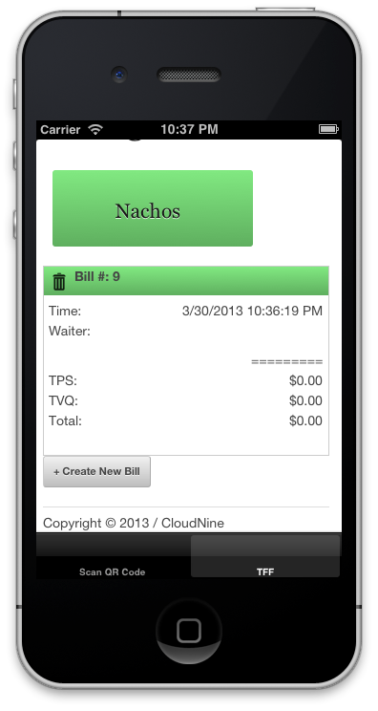

Figure 2‑29 Creating a New Bill Figure 2‑30 New Bill Created

## Adding Items to a Bill (Requires 2.17)

1. The user adds items to the bill by tapping on the desired item (nachos, in this case) and then tapping on the desired bill.

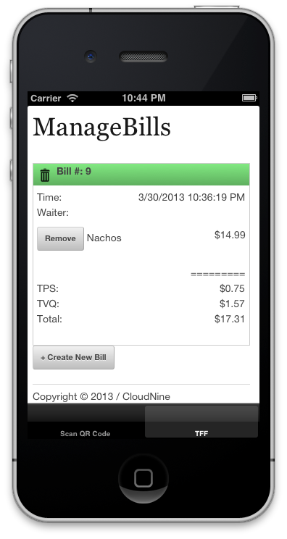

Figure 2‑31 Item Added to a Bill

## Removing an Item from a Bill (Requires 2.18)

1. A user may remove an item from a bill by tapping on the Remove button.



Figure 2‑32 Bill Before Removing Item Figure 2‑33 Bill After Removing Item

## Viewing User Profile (Requires 2.1)

1. A user may view his/her profile by tapping on the name displayed at the top right of the TFF application.

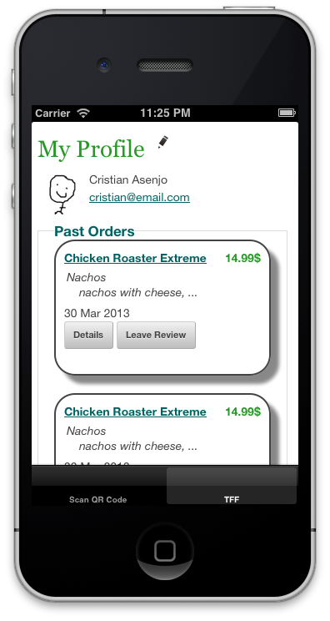

Figure 2‑34 Viewing a Profile after tapping on the User's Name

## Editing a User Profile (Requires 2.20)

1. A user may edit his/her profile details by tapping on the pencil icon beside the My Profile heading while viewing his/her profile.

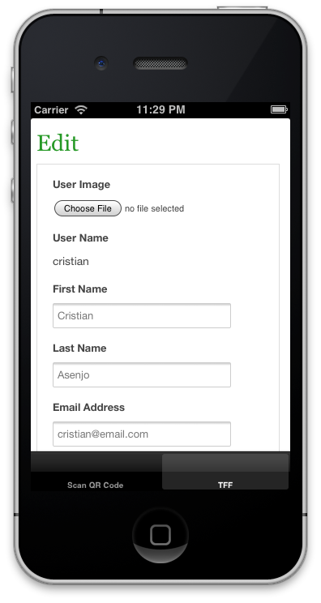

Figure 2‑35 Editing a User Profile

## Viewing Past Orders (Requires 2.18 as well as having paid for it)

1. A user may view his/her past orders by viewing the main user profile page and scrolling to the Past Orders section.

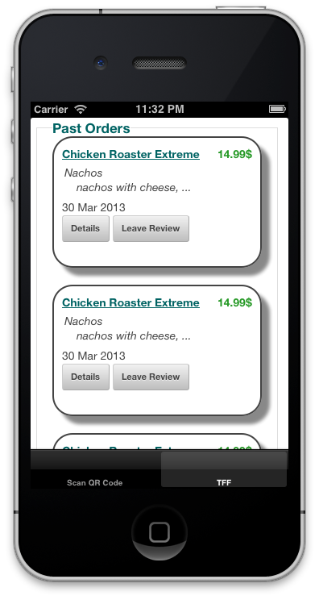

Figure 2‑36 Viewing Past Orders

## Leaving a Review (Requires 2.22)

1. A user may leave a review on an order as long as it has been completed successfully. The user visits his/her profile and presses on the Leave Review button for a past order.



Figure 2‑37 Picking Past Order to Review

1. The user then fills out the form consisting of a comments textbox and a star rating. The user must press the button associated to a specific dish in order to review that dish. Finally the user must press the Create button to create the review.

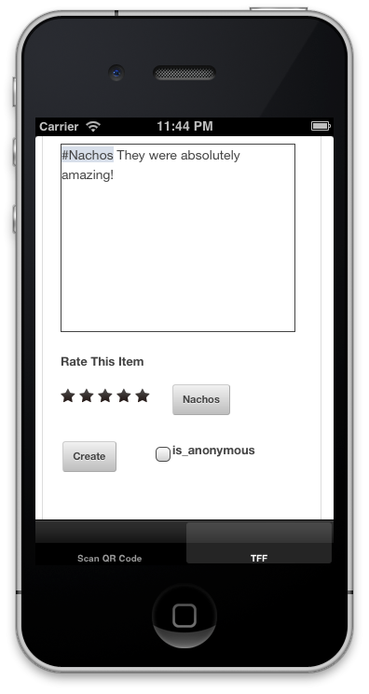

Figure 2‑38 Creating a Review

## Viewing Past Reviews (Requires 2.23)

1. A user may view his/her past reviews by visiting his/her user profile and scrolling down to the section labeled Past Reviews.

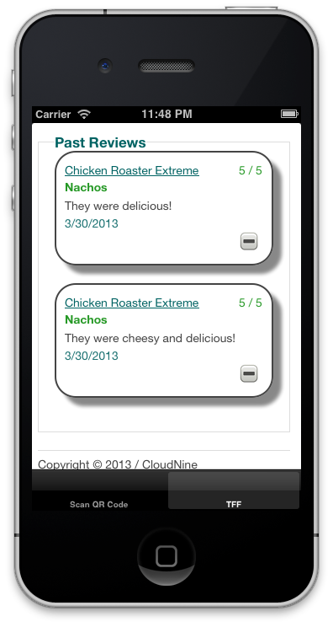

Figure 2‑39 Viewing Past Reviews

# Using TFF as a Restaurant

## Logging In to TFF

1. Access the main TFF website and click on the door icon at the top right of the home page.

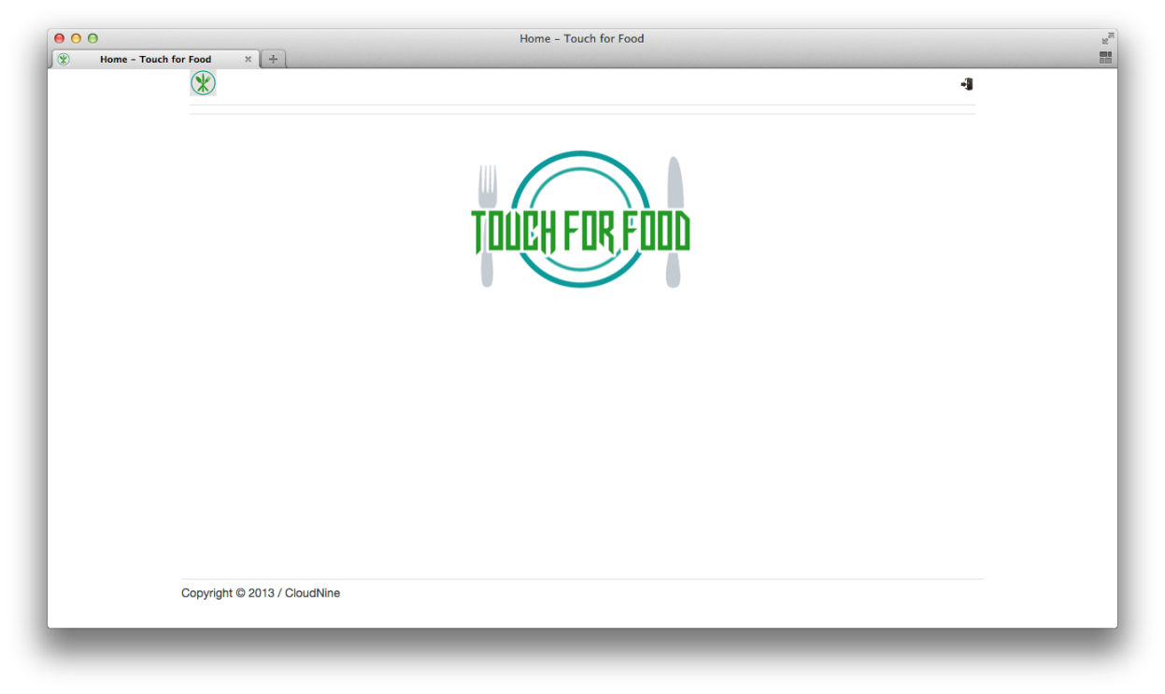

Figure 3‑1 Home Page

1. Log in using your restaurant’s user account information.

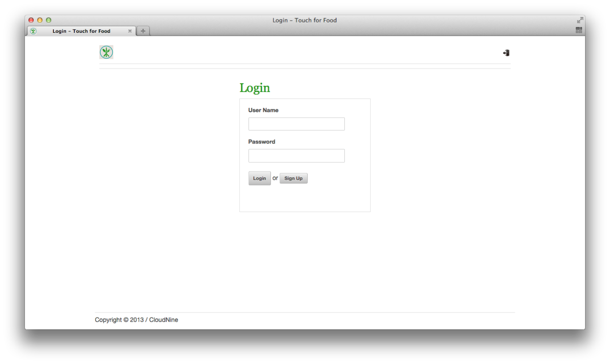

Figure 3‑2 Login Page

## Creating a New Menu (Requires 3.1)

1. From the home page click on the Menus link.

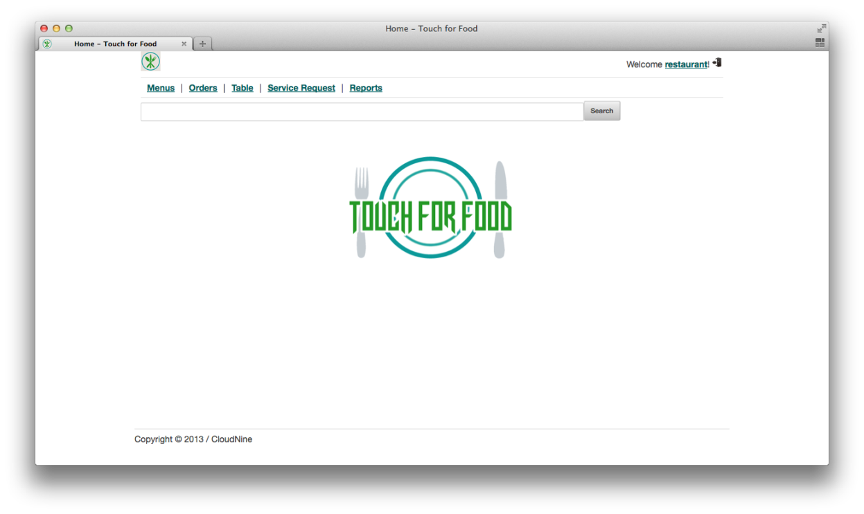

Figure 3‑3 Home Page

1. Click on the Create New Menu button.

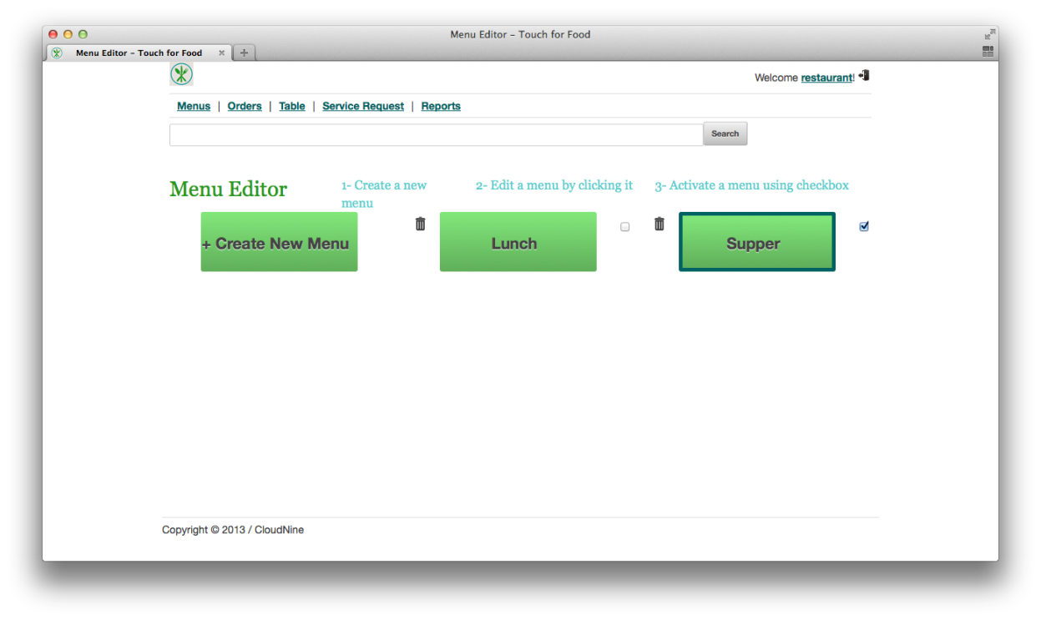

Figure 3‑4 Menus Page

1. Fill in the menu’s name and press the Create button. The new menu is now created.

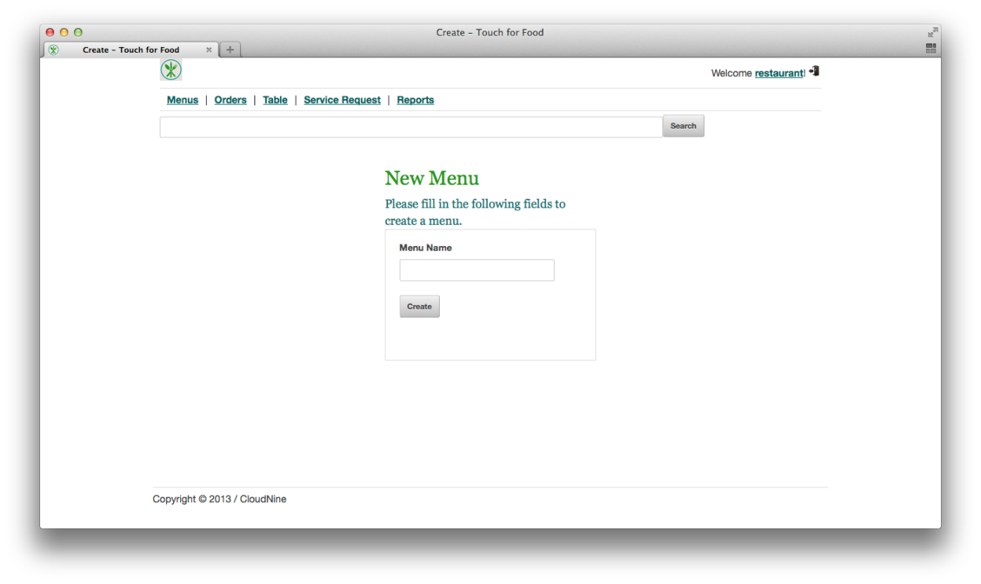

Figure 3‑5 Creating a New Menu

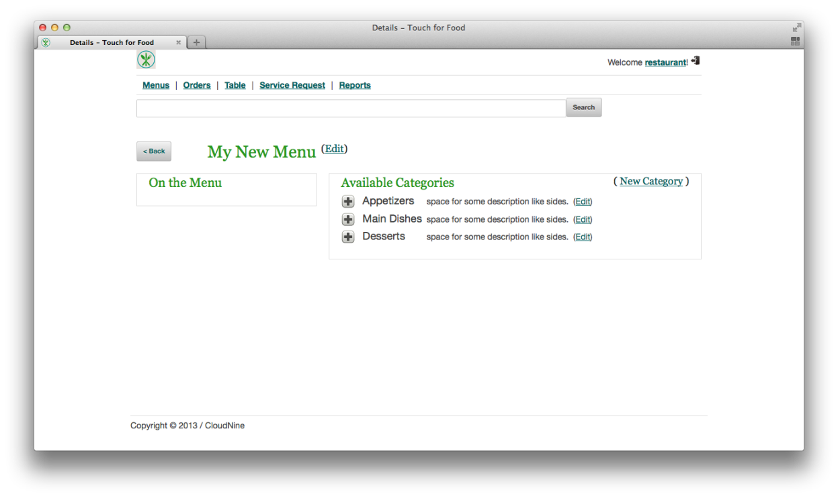

Figure 3‑6 Newly Created Menu

## Activating/Deactivating a Menu (Requires 3.2)

1. To activate a menu simply check the checkbox shown beside it. To deactivate it simply clear the checkbox.

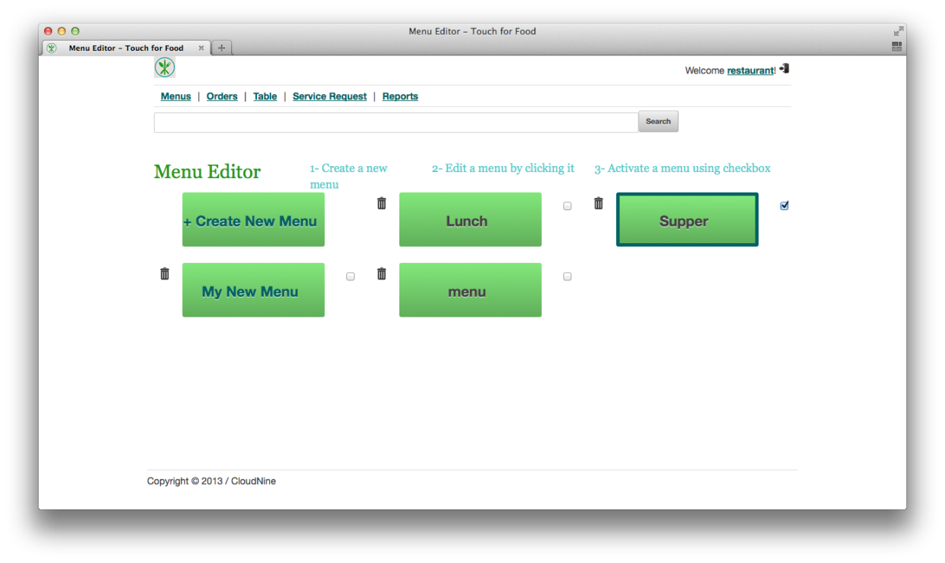

Figure 3‑7 Supper Menu Activated

## Removing a Menu (Requires 3.2)

1. To remove a menu click on the trash can icon beside it. Click the Delete button in order to confirm the removal.

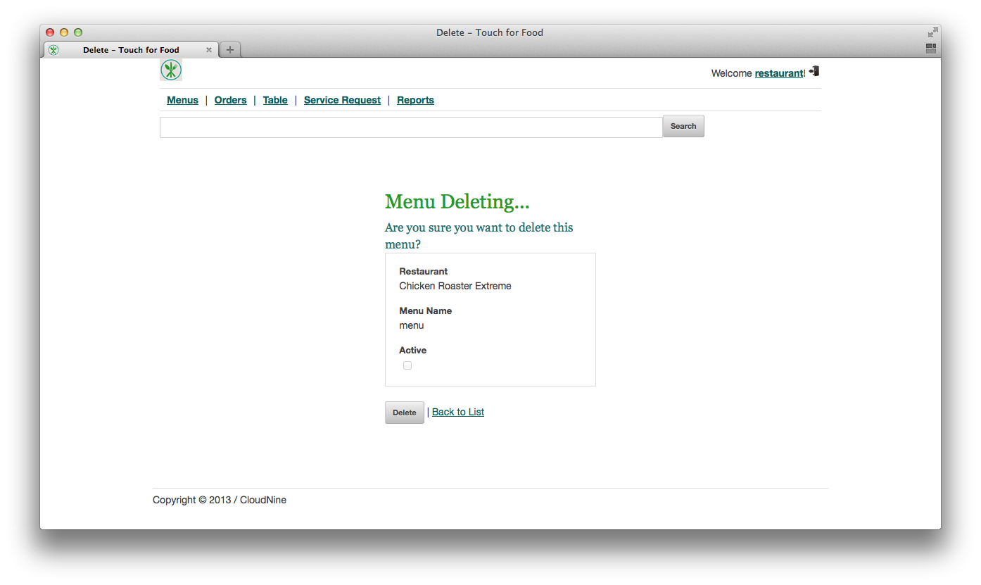

Figure 3‑8 Deleting a Menu

## Creating a Menu Category (Requires 3.2)

1. Access a menu listed in the Menus page, click on the New Category link. Fill in the new category’s name and press the Create button. The category will automatically be added to the current menu being modified.

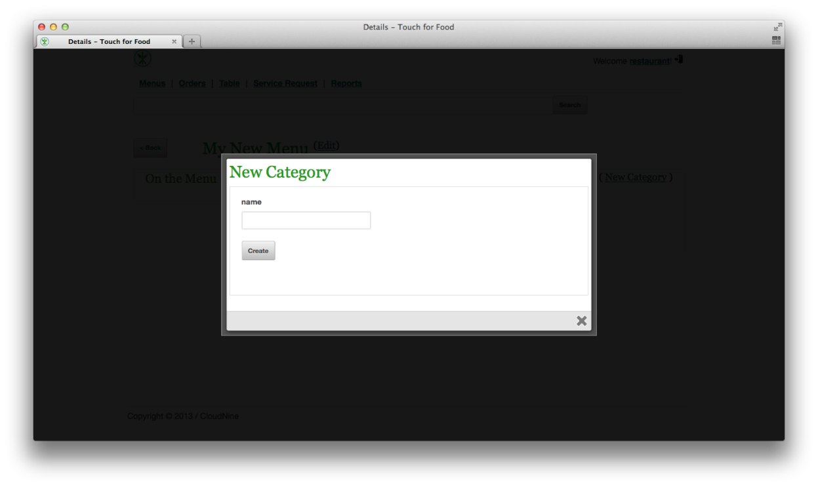

Figure 3‑9 Creating a New Category

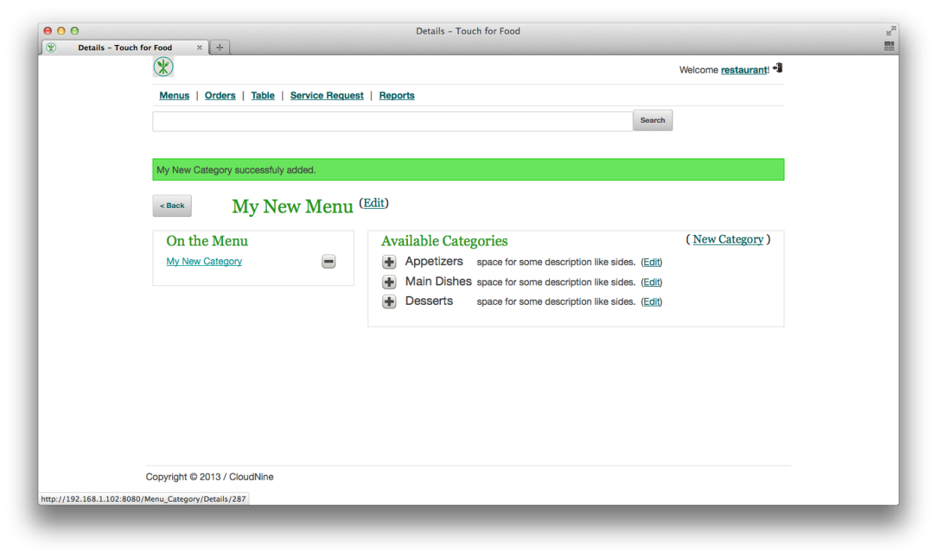

Figure 3‑10 New Category Created

## Adding a Menu Category (Requires 3.5)

1. Access a menu listed in the Menus page and click on the + button beside one of the available categories. The category will be added to the menu.

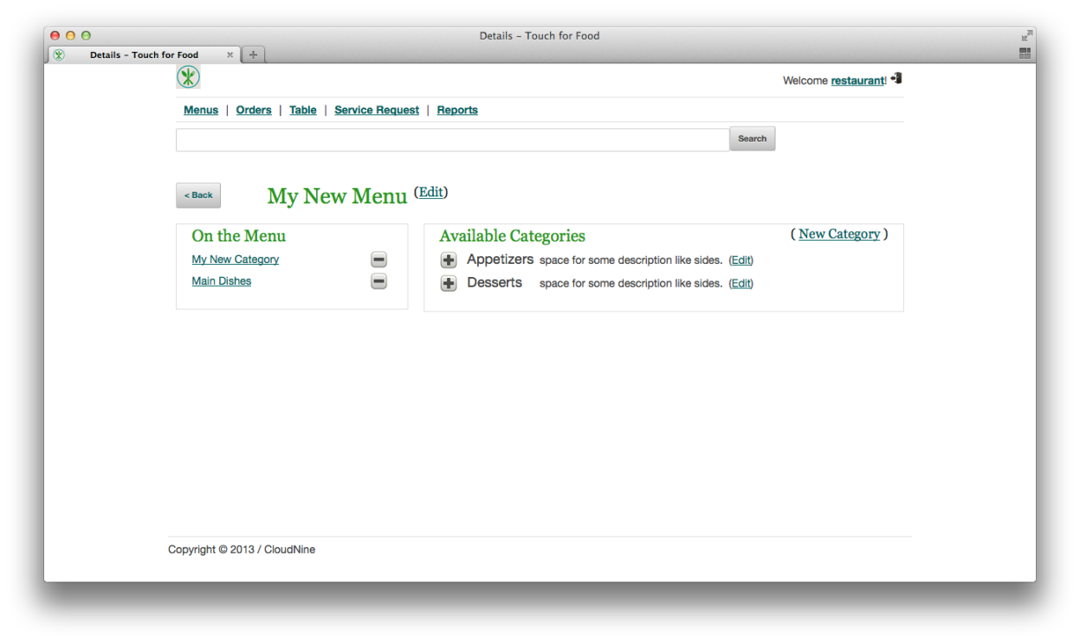

Figure 3‑11 Before Adding a Category

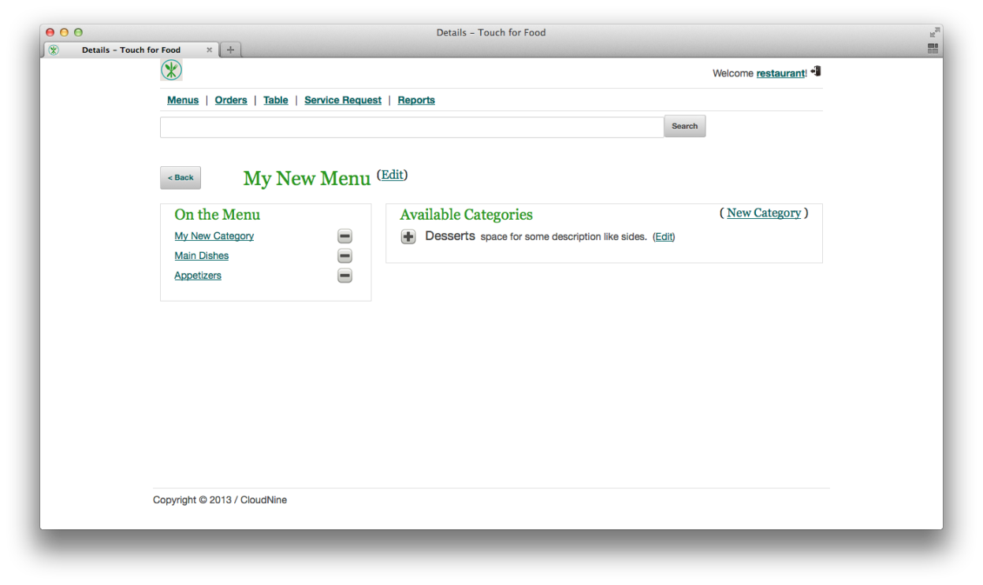

Figure 3‑12 After Adding a Category

## Removing a Menu Category (Requires 3.6)

1. Access a menu listed in the Menus page and click on the – button to remove the category. You will have to confirm your choice by pressing OK when the popup appears. The menu category will then be listed in the Available Categories list on the right.

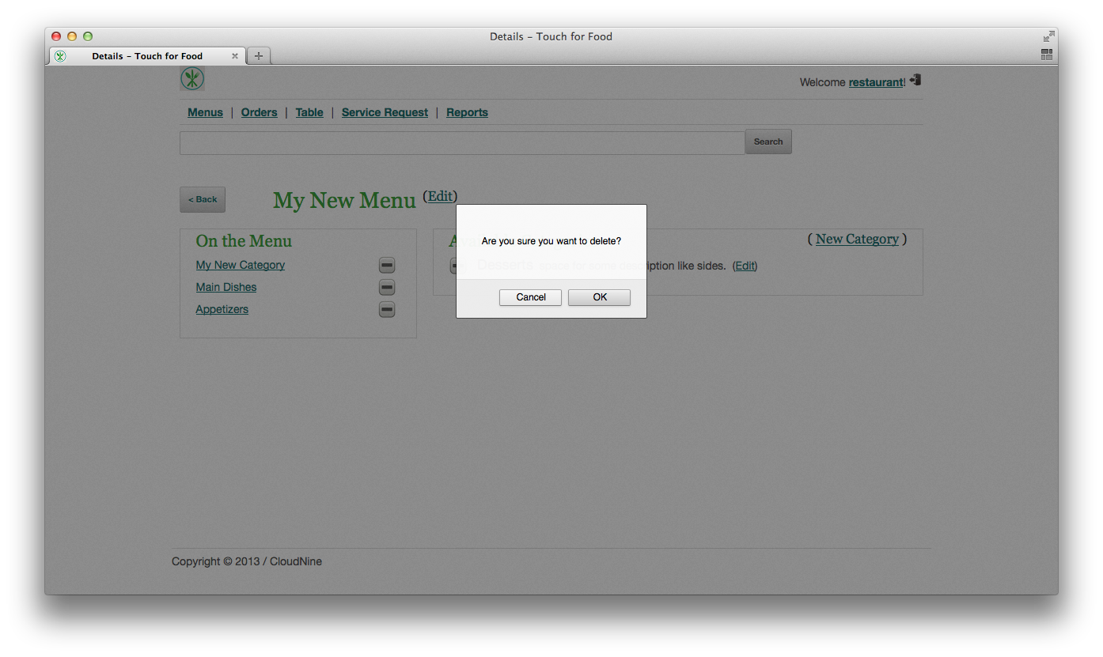

Figure 3‑13 Removing a Category

## Creating Menu Items (Requires 3.5)

1. Access a menu category by going to a menu listed in the Menus page and clicking on category link itself under the On The Menu section. A category must be added to a menu before you can create items for it.

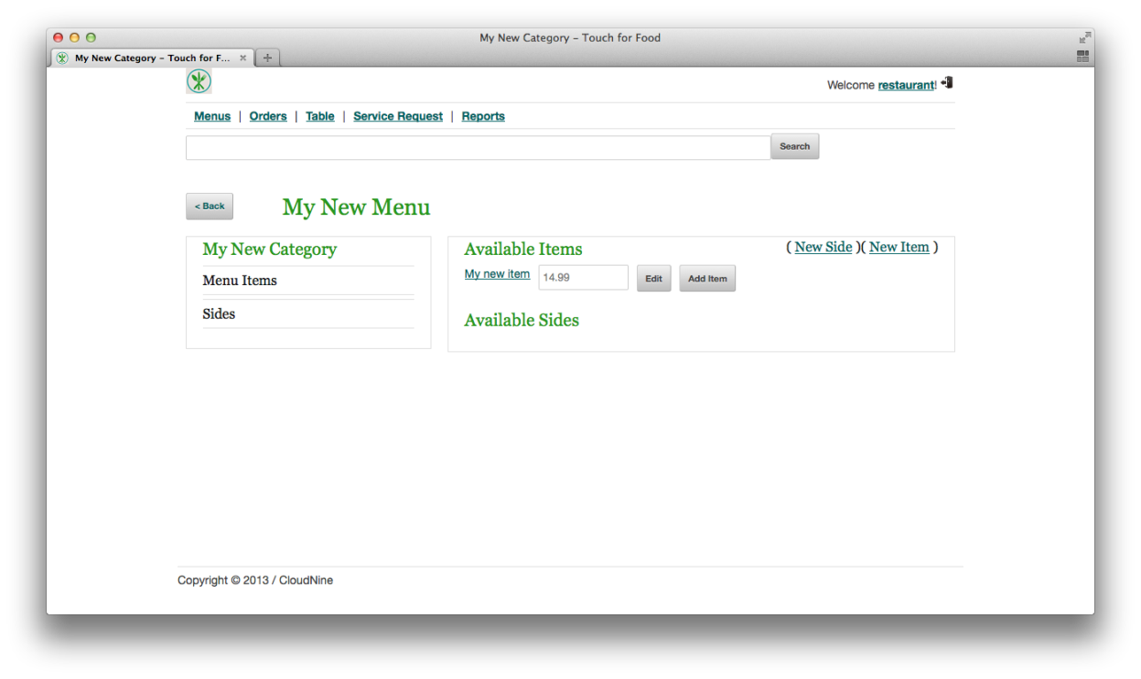

Figure 3‑14 Viewing a Menu Category

1. Click on the New Item link, fill out the details and click on the Create button to create the new item.

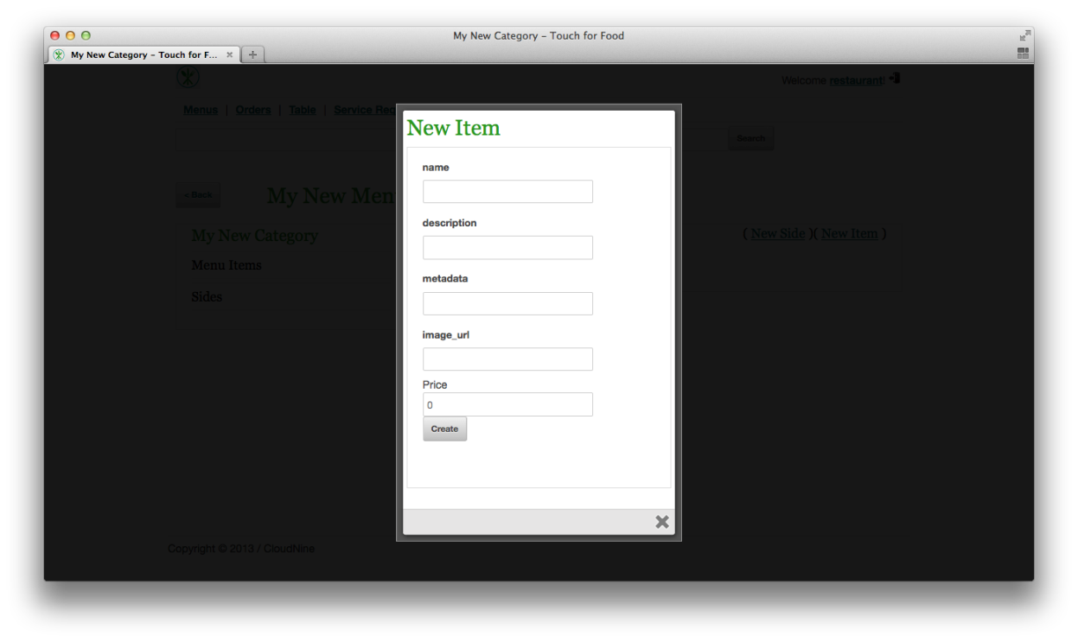

Figure 3‑15 Creating a New Item

1. The new item will automatically be added to the menu.

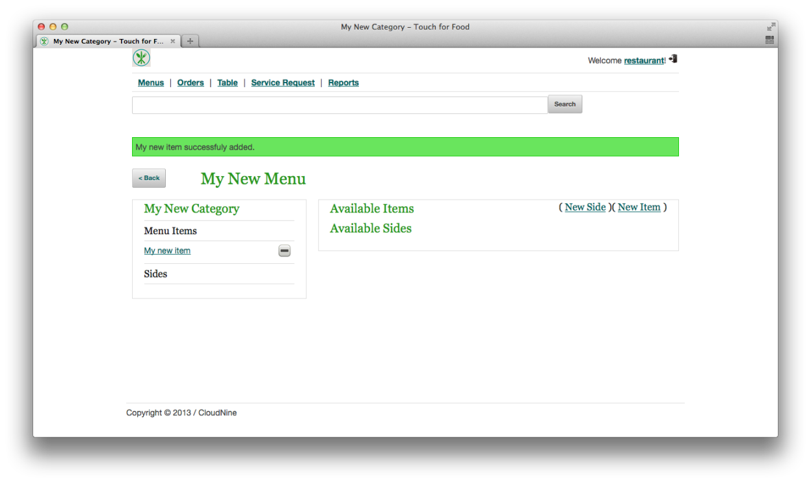

Figure 3‑16 New Menu Item Added

## Adding Menu Items to a Menu Category (Requires 3.8)

1. Access a menu category by going to a menu listed in the Menus page and clicking on category link itself under the On The Menu section. A category must be added to a menu before you can add items to it.



Figure 3‑17 Viewing a Menu Category

1. Click on the Add Item button to add the item to the menu category.

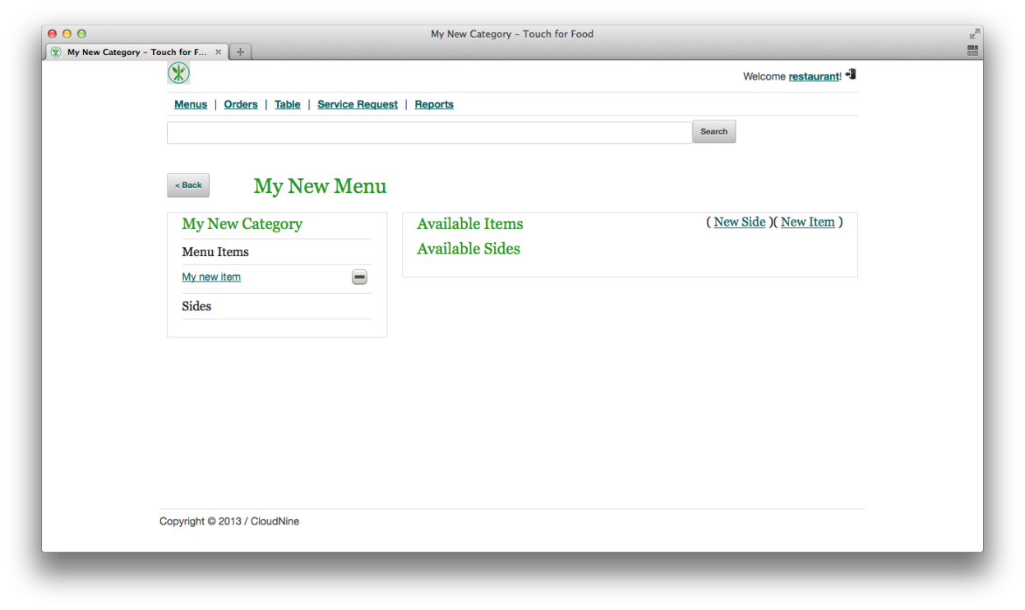

Figure 3‑18 After Pressing the Add Item Button

## Removing Menu Items from a Category (Requires 3.9)

1. Access a menu category listed in a menu and then click on the - button beside the menu item you wish to remove. You will have to confirm your choice by pressing OK when the popup appears. The removed menu item will be listed in the Available Items list on the right.

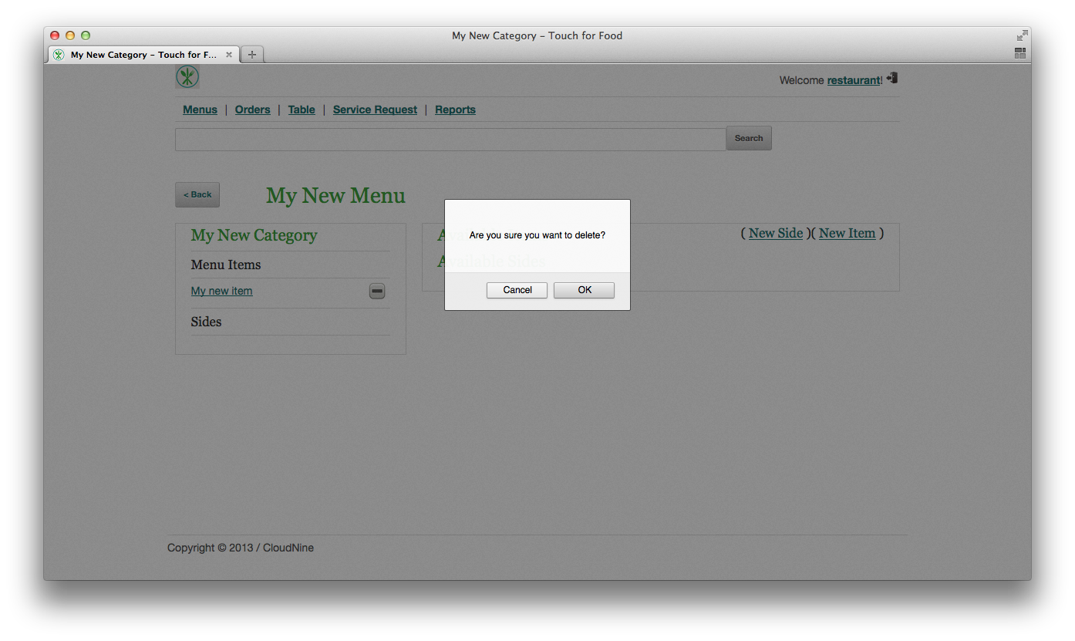

Figure 3‑19 Deleting a Menu Item

## Creating a Menu Side (Requires 3.5)

1. Access a menu category listed in a menu and then click on the New Side link to create a new side. It will automatically be added to the current menu.

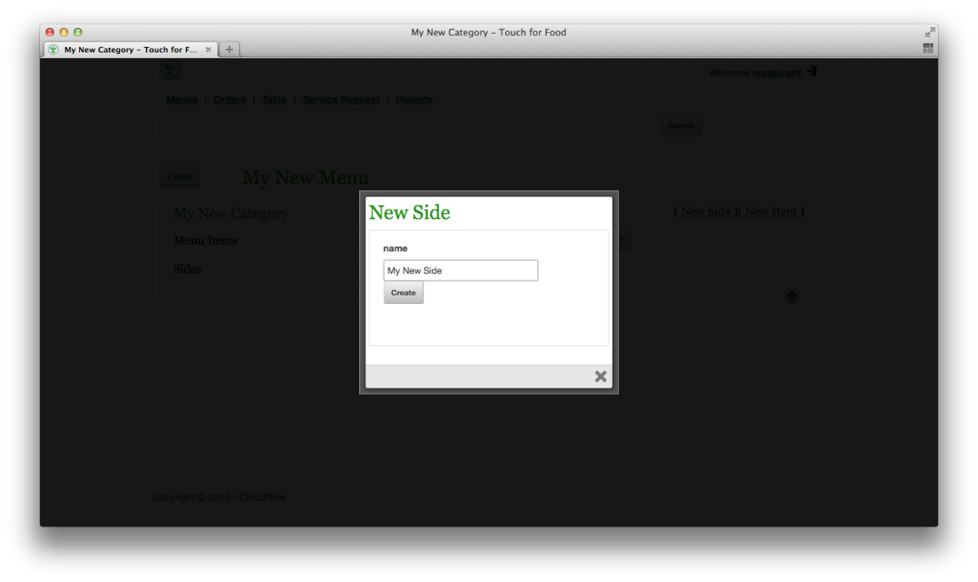

Figure 3‑20 Creating a New Side

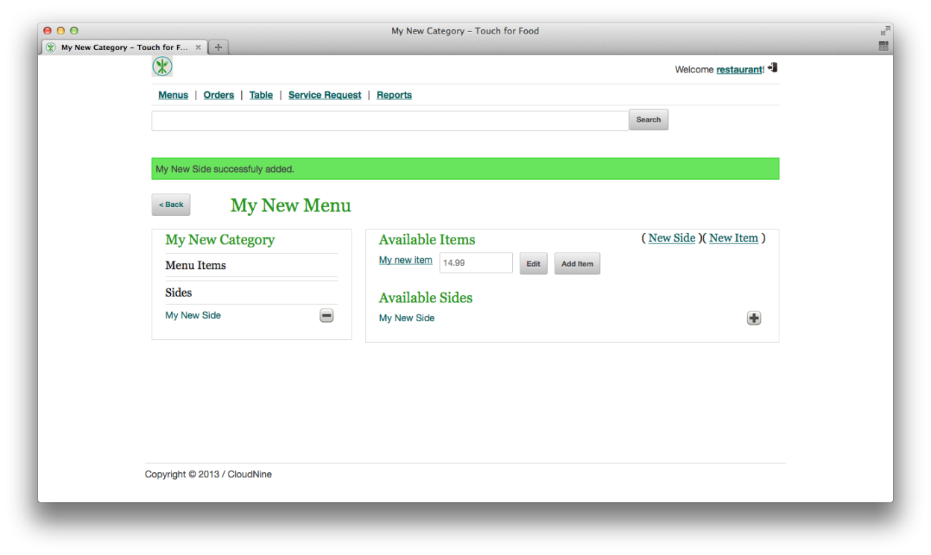

Figure 3‑21 New Side Successfully Added

## Adding a Menu Side (Requires 3.11)

1. Access a menu category listed in a menu and then click on the + button beside an available side to add it to the current menu.

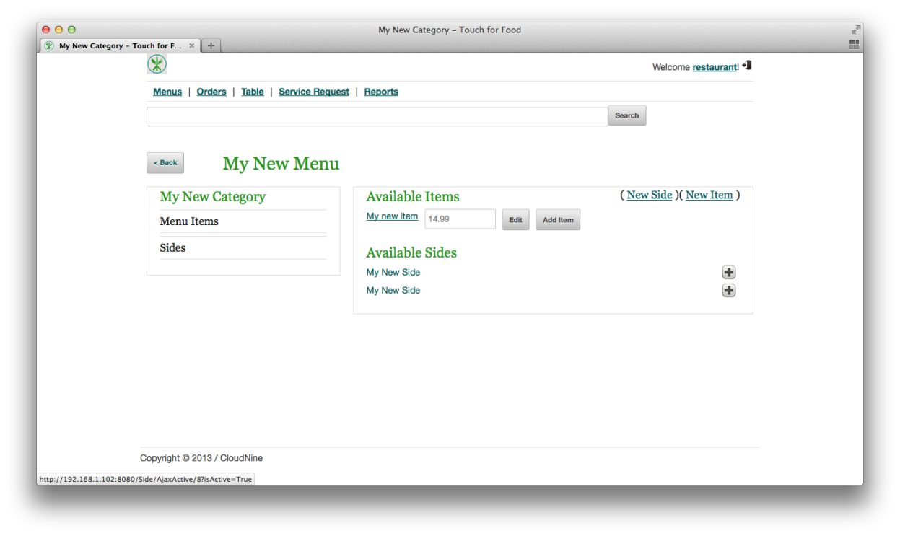

Figure 3‑22 Before Adding a Side

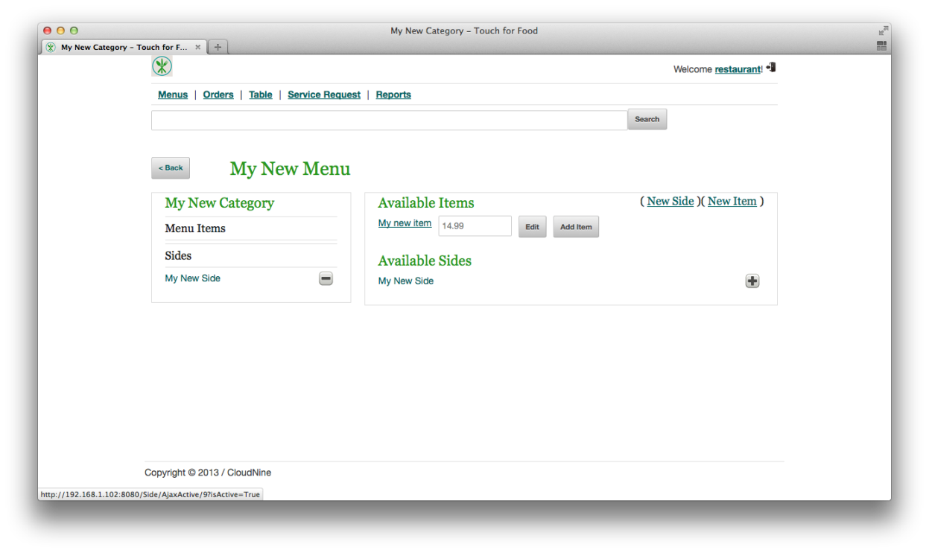

Figure 3‑23 After Adding a Side

## Removing a Menu Side (Requires 3.12)

1. Access a menu category listed in a menu and then click on the - button beside an already added side to remove it from the current menu. You will have to confirm your action by pressing the OK button when the popup appears.

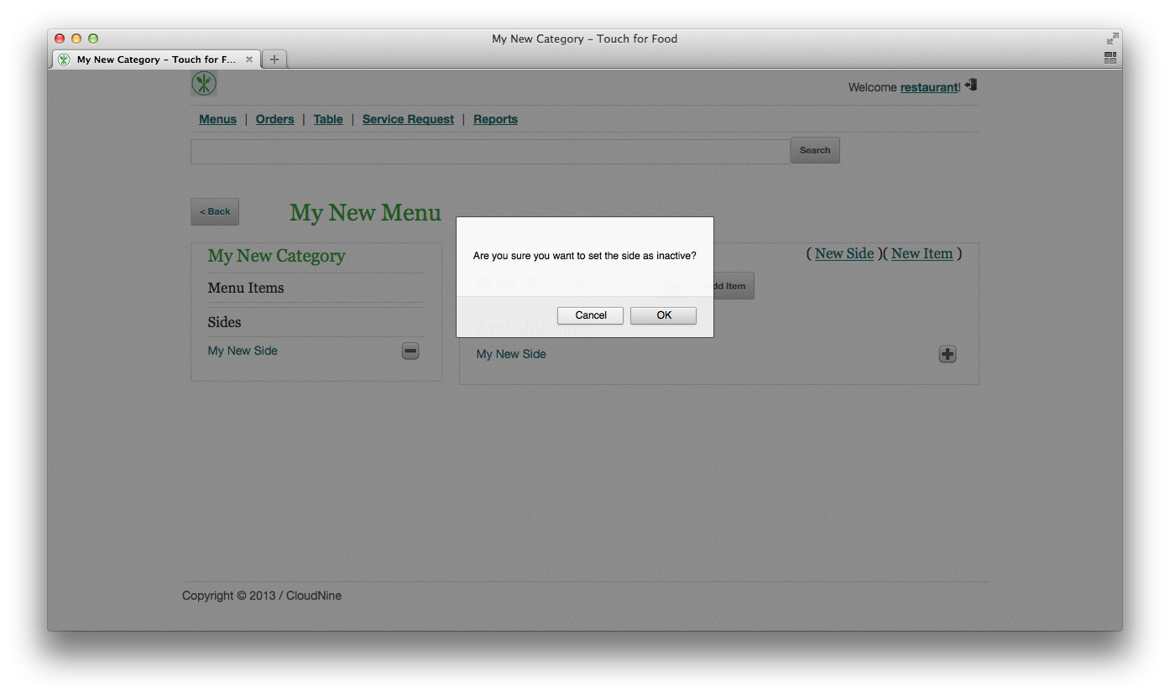

Figure 3‑24 Removing a Menu Side

## Creating Tables (Requires 3.1)

1. Click on the Table link to access the list of existing tables. Click on the Create New link to begin creating a table. Fill in the new table’s information and then click on the Create button.

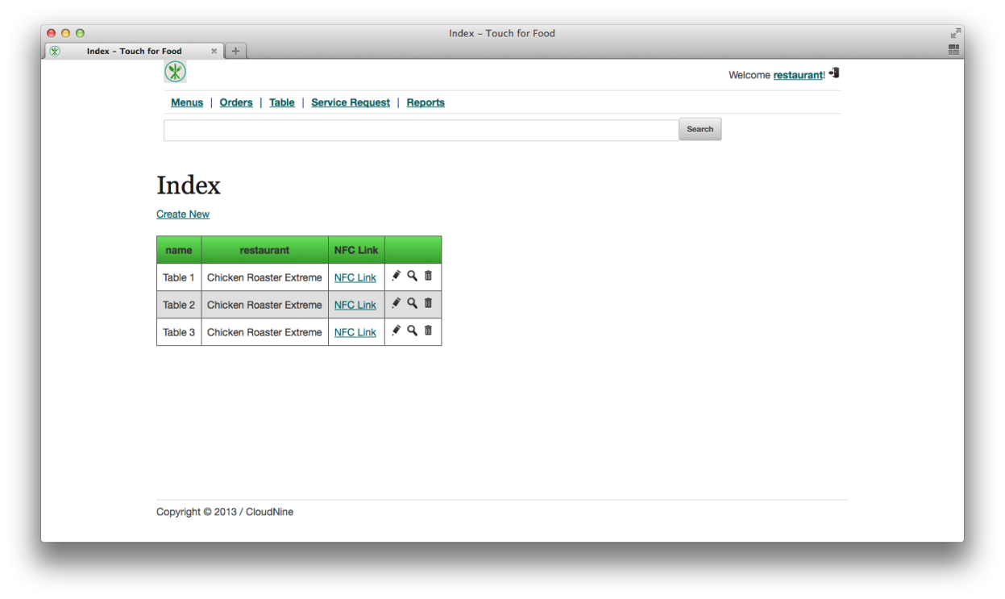

Figure 3‑25 Viewing List of Tables

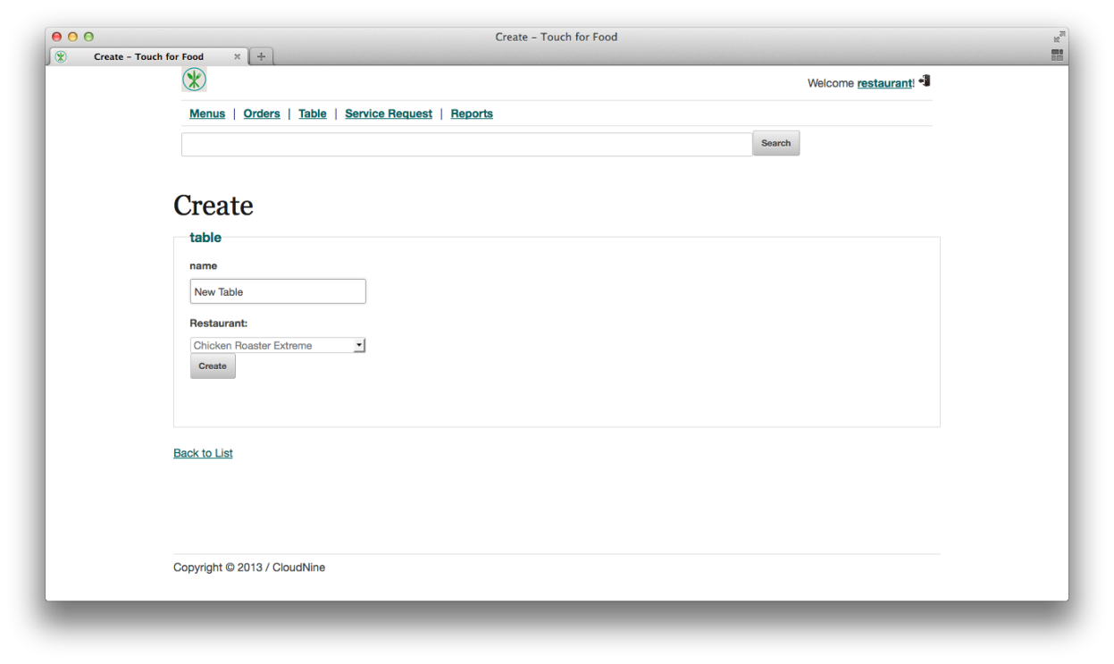

Figure 3‑26 Creating a New Table

## Editing a Table (Requires 3.14)

1. Access the Tables menu and click on the pencil icon beside a table. After finishing your changes click on the Save button to save them.

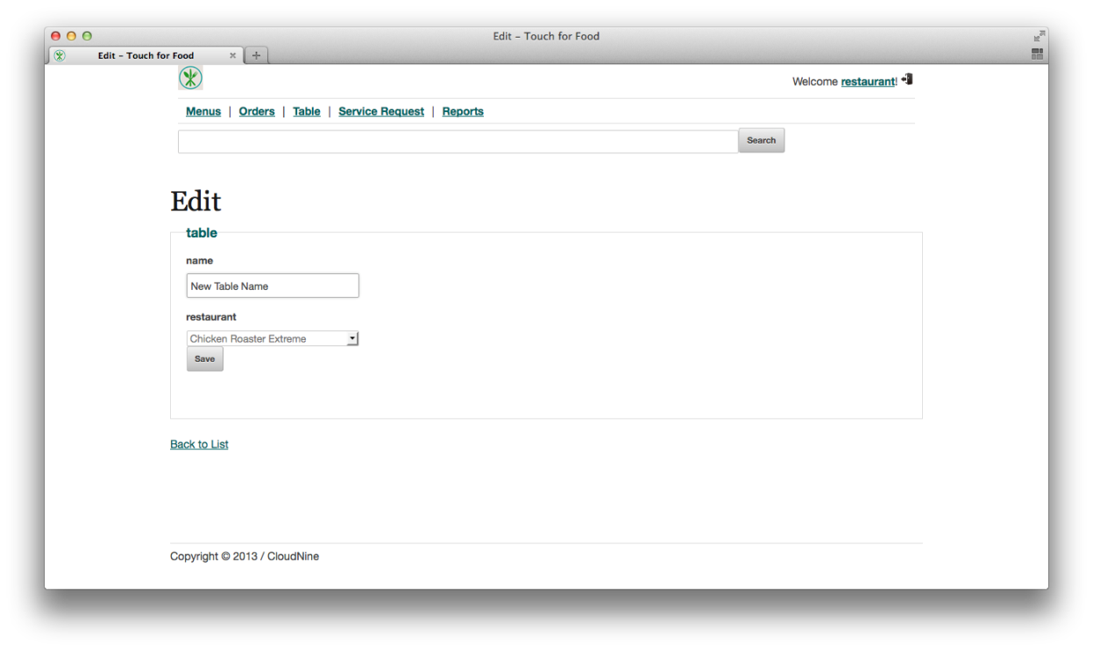

Figure 3‑27 Editing a Table

## Viewing a Table’s Details (Requires 3.14)

1. Access the Tables menu and click on the magnifying glass icon beside a table. Click on the Back to List link to return to the list of tables.

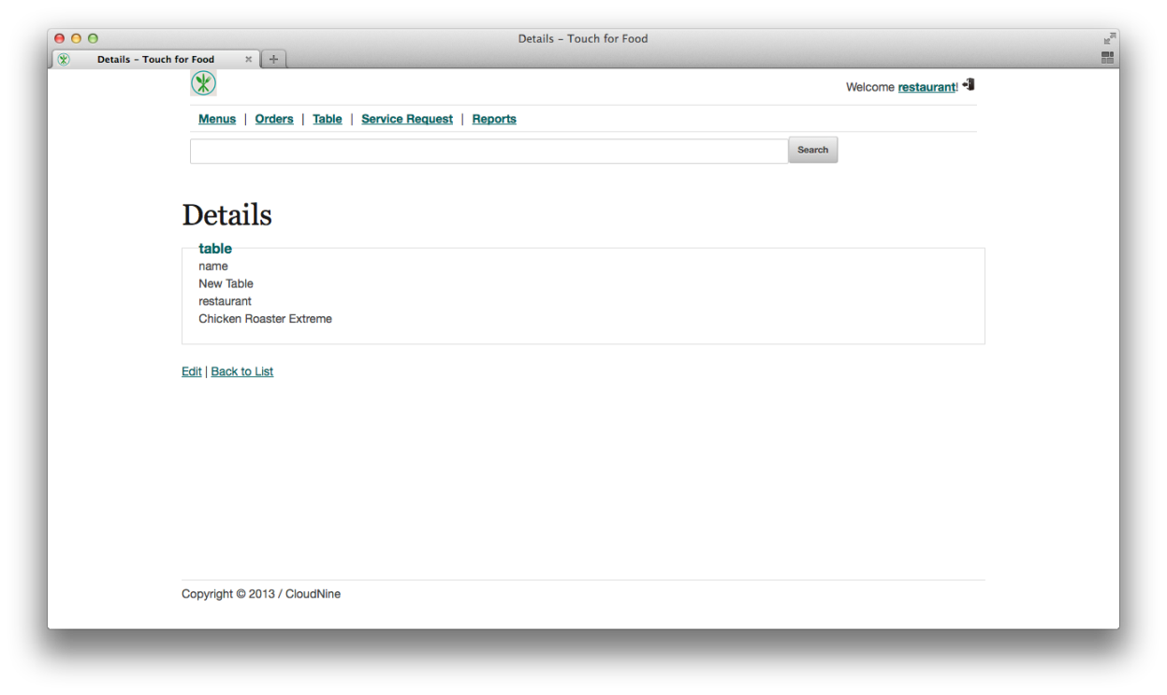

Figure 3‑28 Viewing a Table's Details

## Removing a Table (Requires 3.14)

1. Access the Tables menu and click on the trashcan icon beside a table. Confirm your action by pressing on the Delete button.

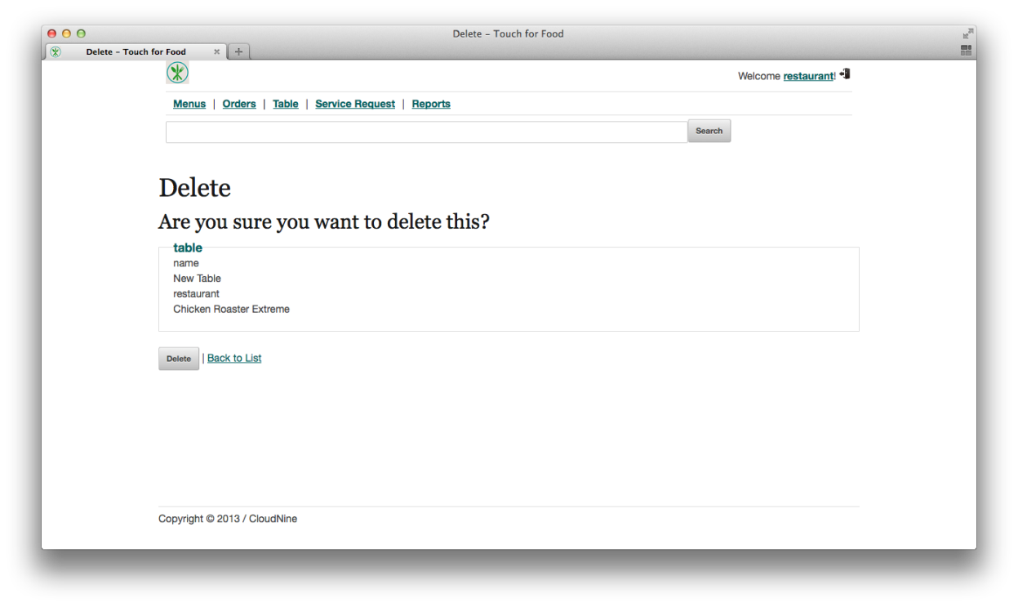

Figure 3‑29 Deleting a Table

## Managing Orders (Requires 2.5, 3.9, 3.14)

1. Click on the Orders link to manage current orders. To view orders from a specific table, the table buttons on the left can be used.

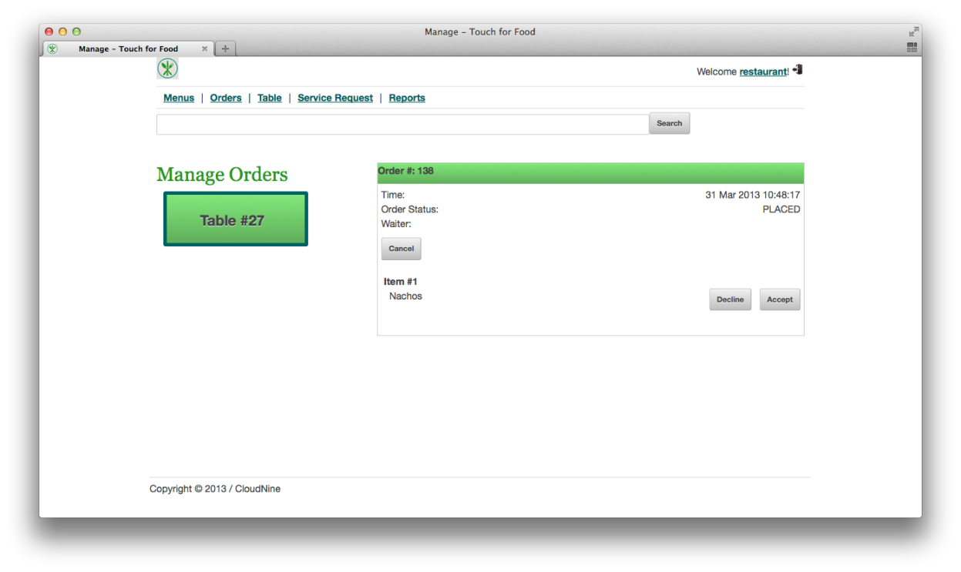

Figure 3‑30 Manage Orders Page

1. From here an order may be cancelled (pressing the Cancel button), an item may be declined (pressing the Decline button), or an item may be accepted (pressing the Accept button). When an item has been accepted and then delivered by a waiter, then it may also be flagged as delivered (by pressing the Delivered button).

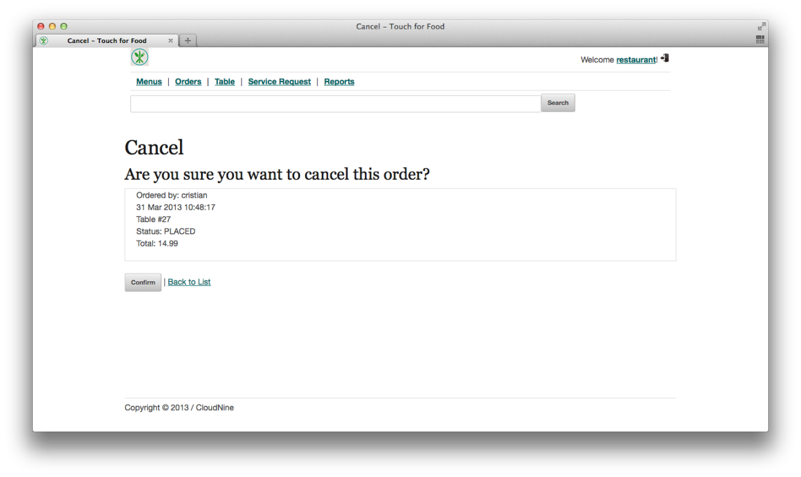

Figure 3‑31 Canceling an Order

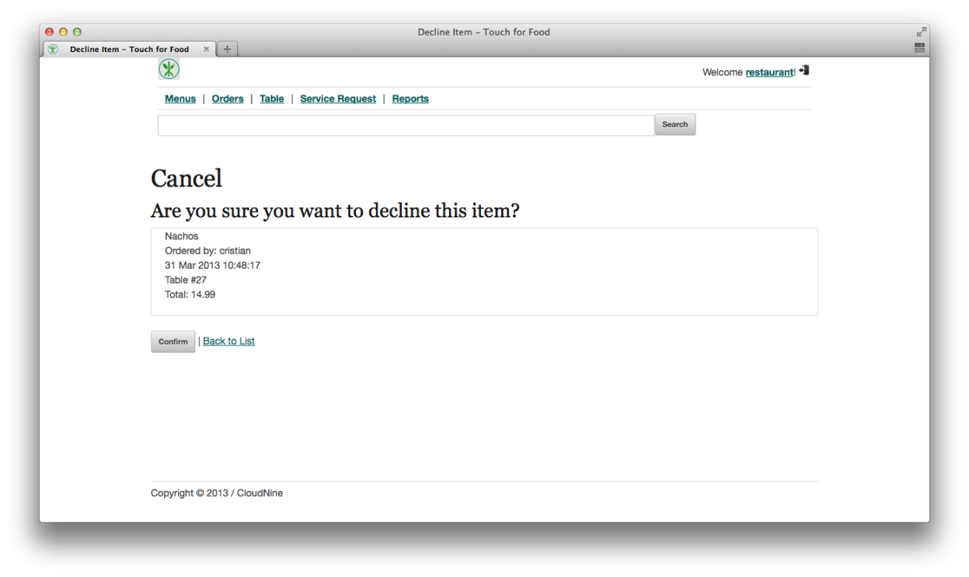

Figure 3‑32 Declining an Item

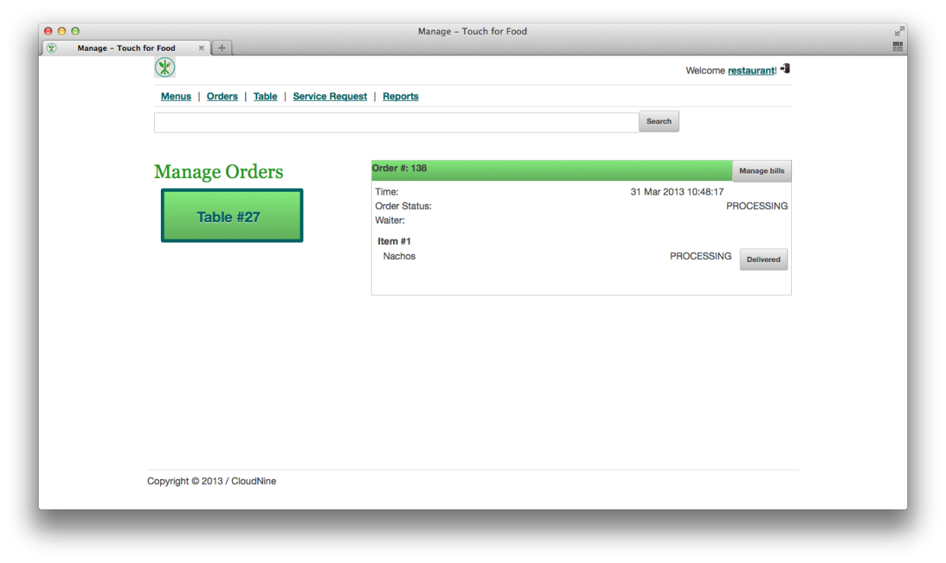

Figure 3‑33 Accepted an Item (still undelivered)

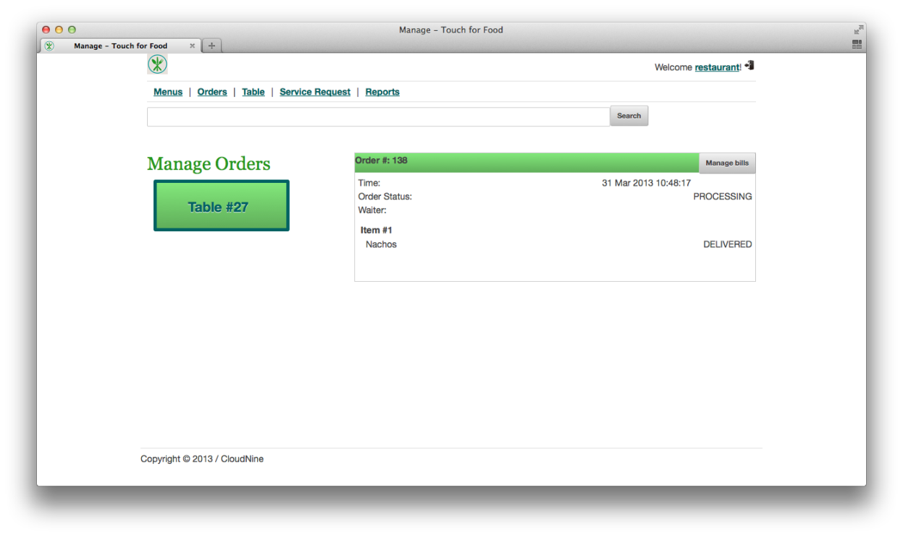

Figure 3‑34 Delivered Item

## Managing Service Requests (Requires 2.10 and 3.14)

1. Click on the Service Request link to manage current service requests.

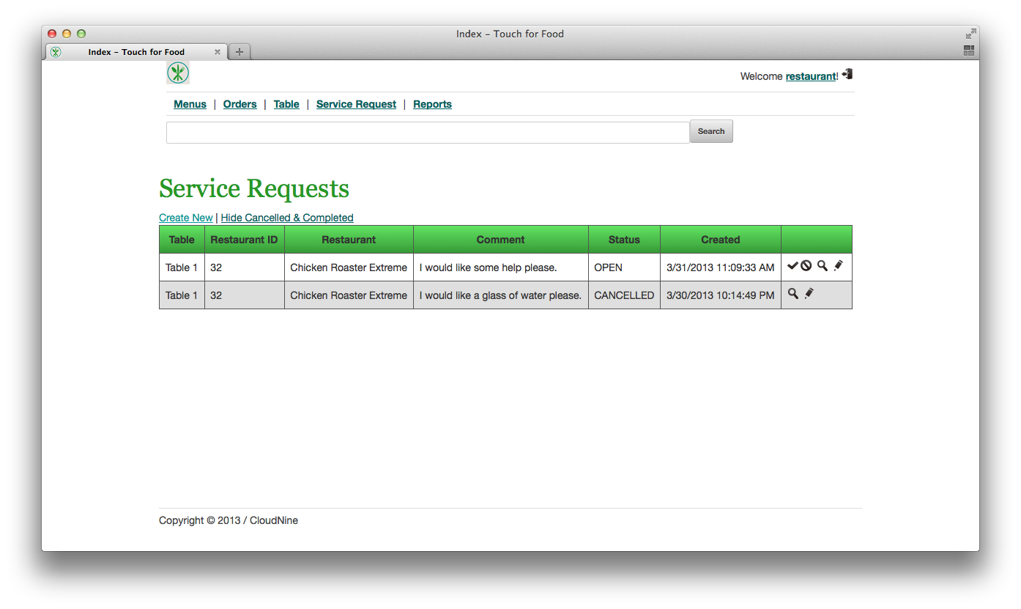

Figure 3‑35 Viewing Service Requests

1. From here a service request may be completed (pressing on the checkmark icon and confirming), cancelled (pressing on the No icon and confirming), viewed (pressing on the magnifying glass icon and confirming) and edited (pressing on the pencil icon and confirming). A new service request may also be created by clicking on the Create New link, filling the details and clicking on the Create button.

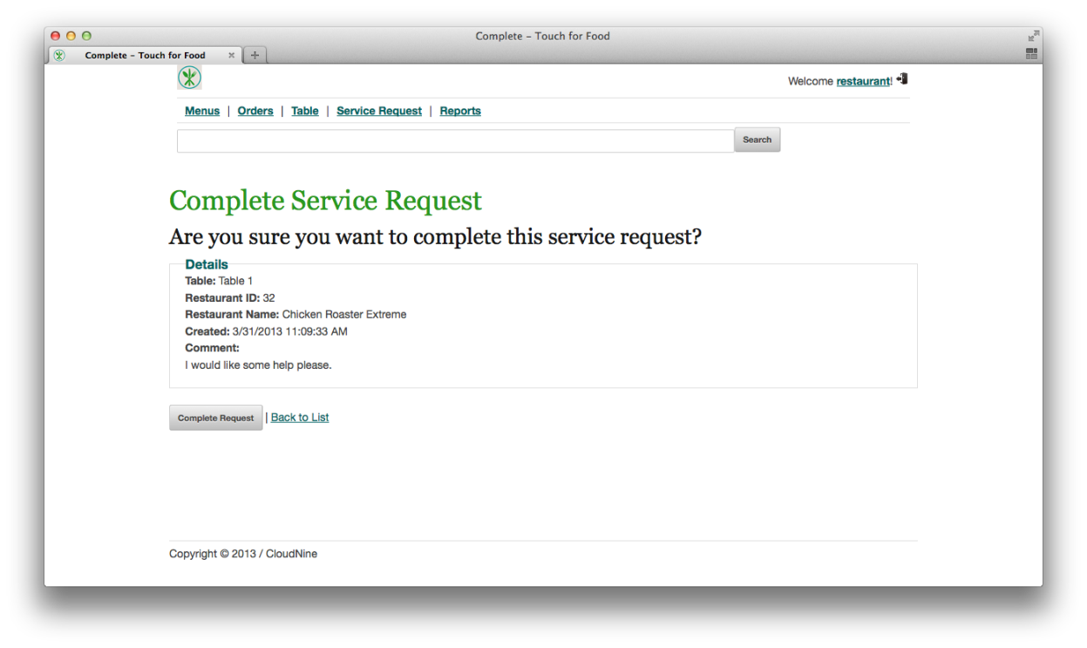

Figure 3‑36 Completing a Service Request

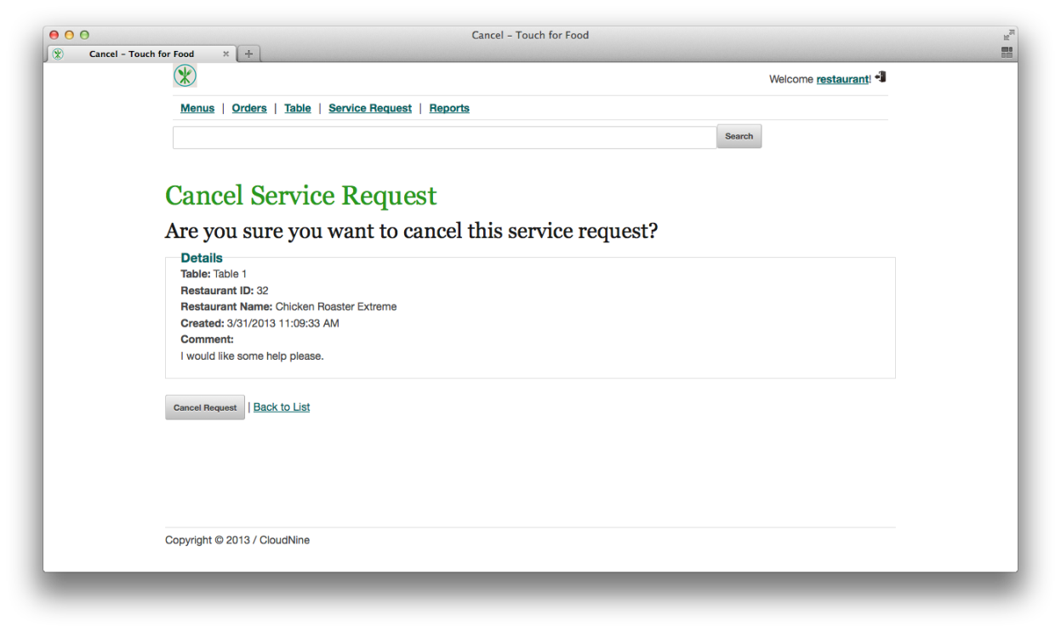

Figure 3‑37 Cancelling a Request

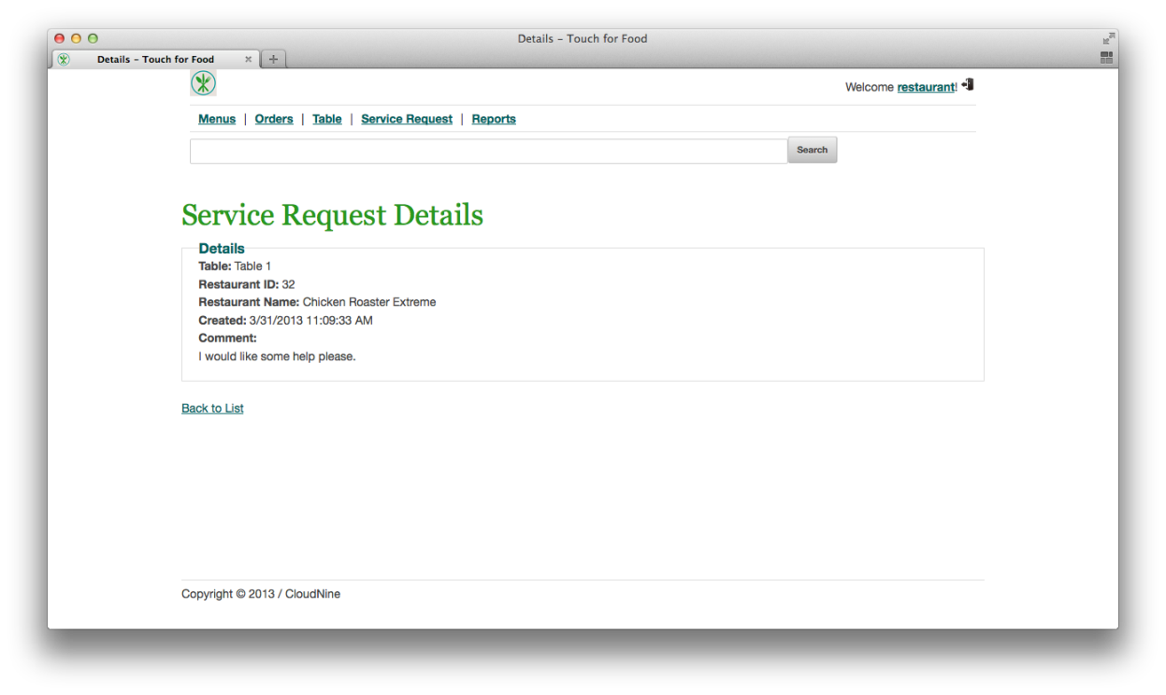

Figure 3‑38 Viewing a Service Request's Details

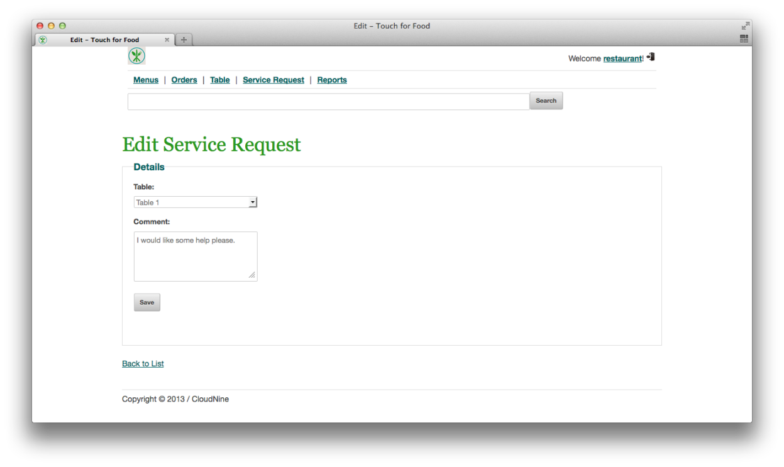

Figure 3‑39 Editing a Service Request

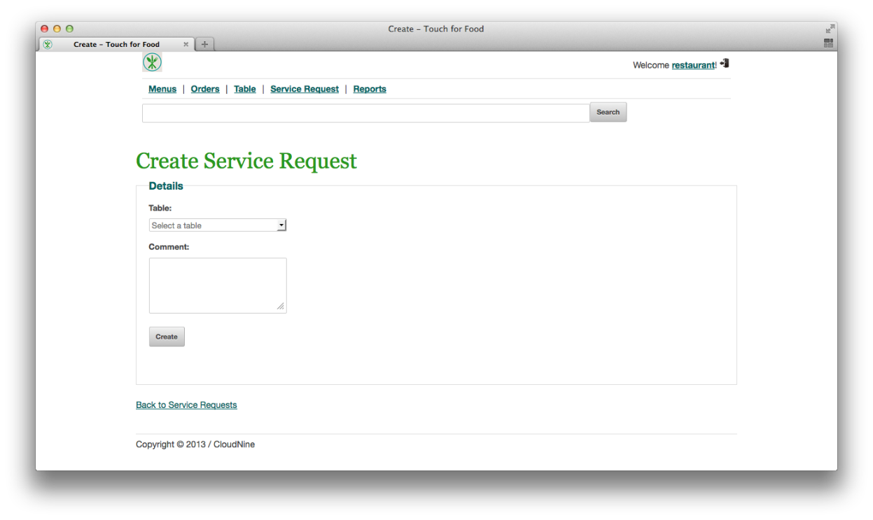

Figure 3‑40 Creating a New Service Request

## Managing a Table’s Bills (Requires 3.18)

1. Once an item has been accepted (but not necessarily delivered), the restaurant may manage a table’s bill. Click on the Manage Bills button to do so.



Figure 3‑41 Viewing a Table's Orders

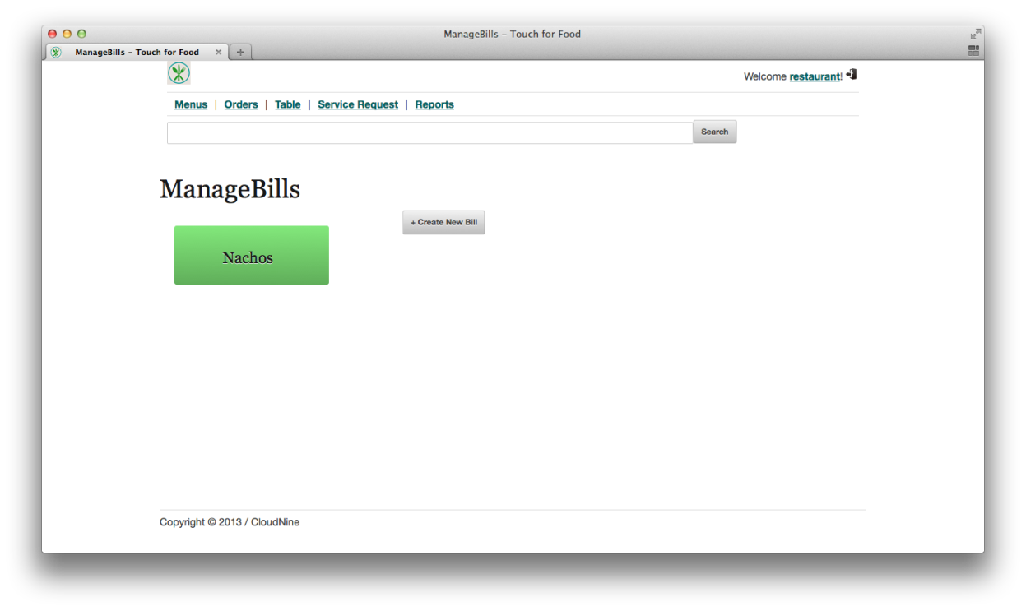

Figure 3‑42 Managing a Table's Bills

## Creating a Bill (Requires 3.20)

1. A restaurant may create a bill by tapping on the Create New Bill button and then clicking on OK when the question “Are you sure you want to add?” appears.

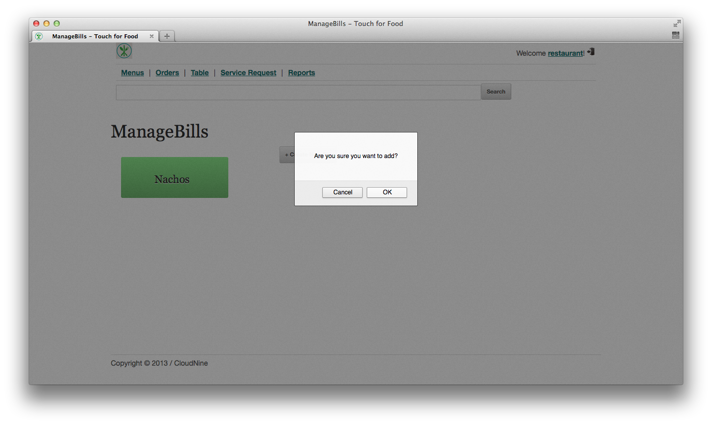

Figure 3‑43 Creating a Bill

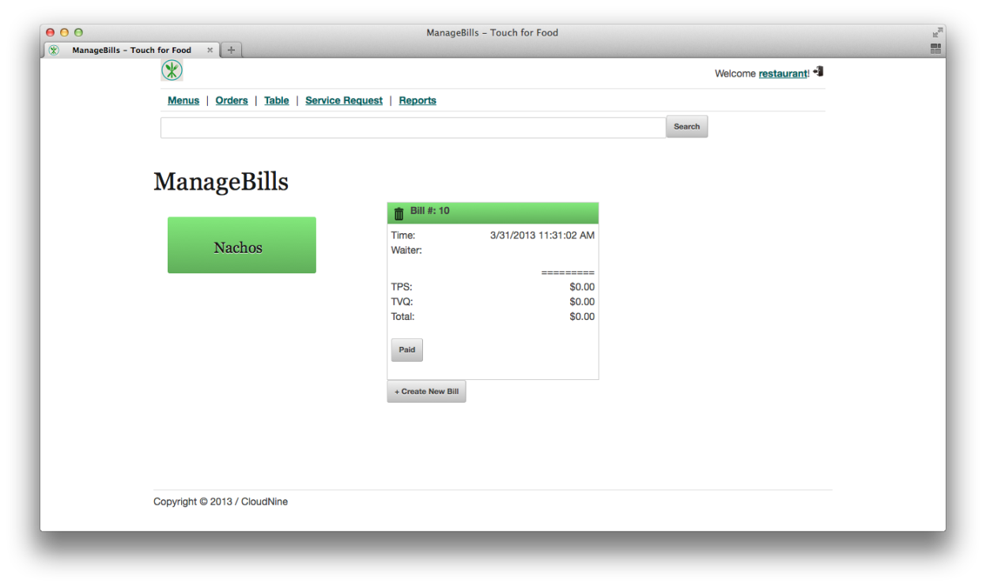

Figure 3‑44 New Bill Created

## Adding Items to a Bill (Requires 3.21)

1. The restaurant adds items to the bill by tapping on the desired item (nachos, in this case) and then tapping on the desired bill.

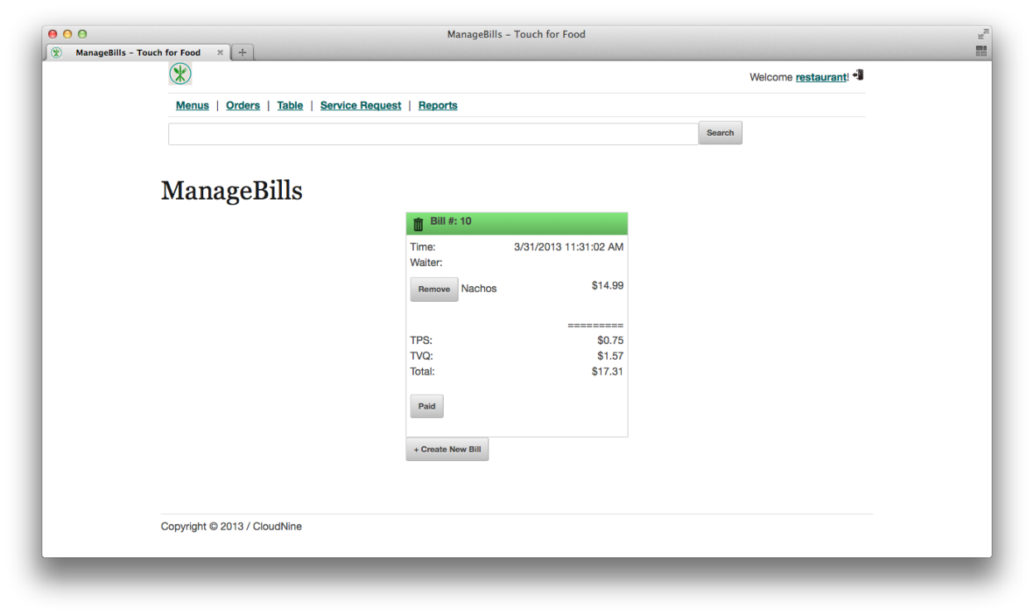

Figure 3‑45 Item Added to a Bill

## Removing an Item from a Bill (Requires 3.22)

1. A restaurant may remove an item from a bill by clicking on the Remove button.



Figure 3‑46 Before Removing Item



Figure 3‑47 After Removing Item

## Viewing Report for Most Popular Dish (Requires 2.14 at least once)

1. To view the most popular dish, click on the Reports link and then on the Most Popular Dish link. Select your restaurant and click on Create.

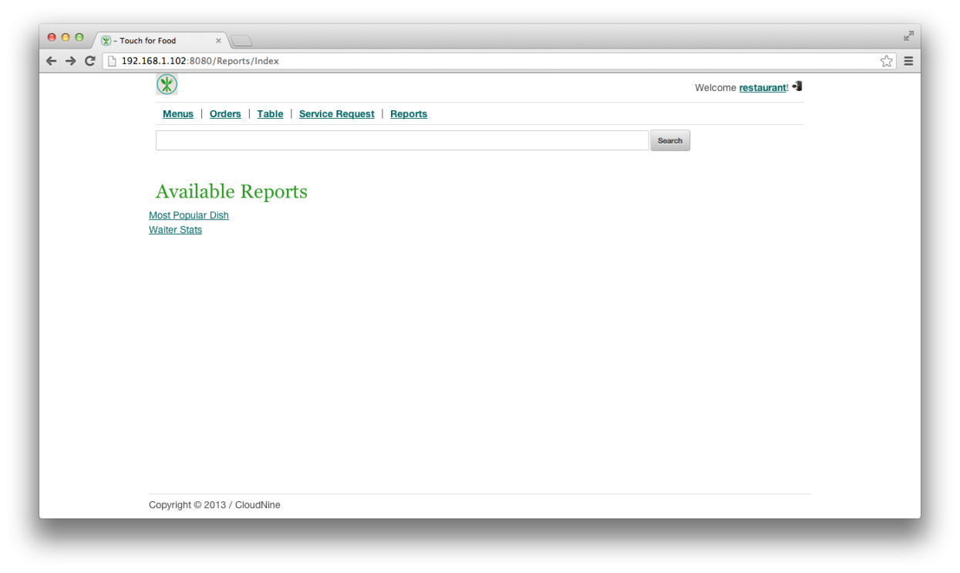

Figure 3‑48 Reports Menu

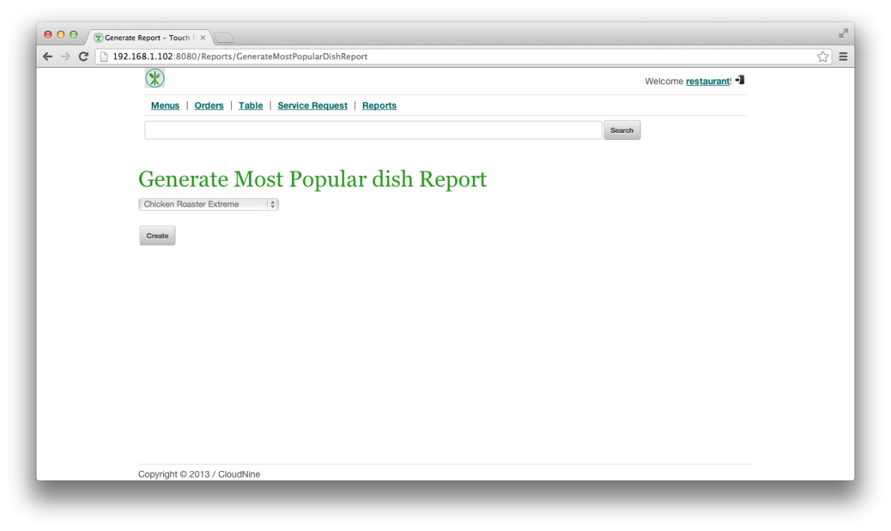

Figure 3‑49 Creating the Report

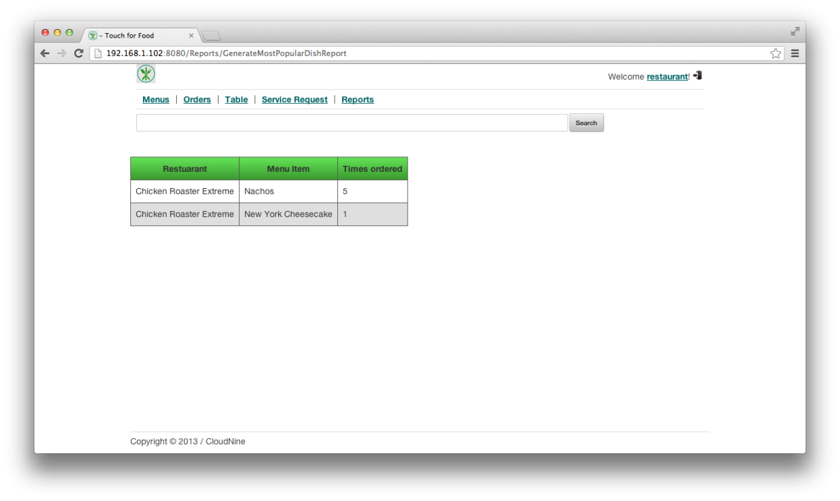

Figure 3‑50 Viewing Most Popular Dishes Report

## Viewing Waiter Statistics Report (Requires 2.10 at least once)

1. To view waiter statistics, click on the Reports link and then on the Waiter Stats link. Select your restaurant, then click on the From and To boxes to select the date ranges, and finally click on the Create button.

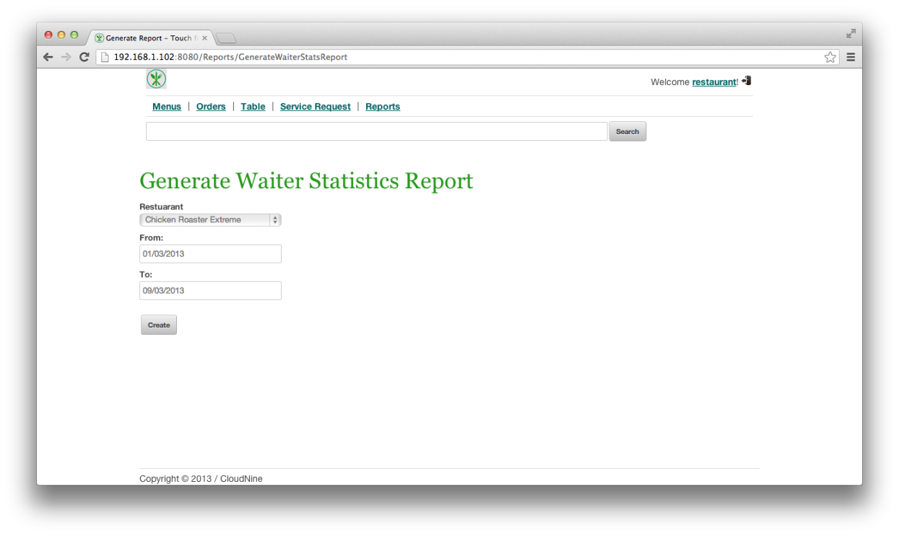

Figure 3‑51 Creating the Waiter Statistics Report

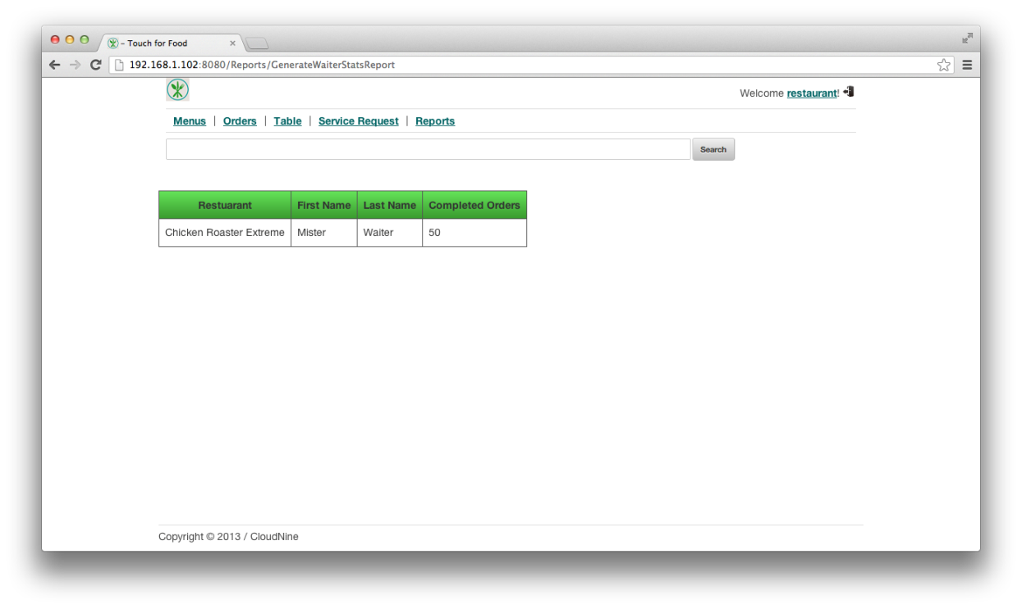

Figure 3‑52 Viewing the Waiter Statistics Report

# Appendix A References

x

|  |  |
| --- | --- |
| [1] | K. Anderson, C. Donato, J.Hum, M. Levkovsky, A. Lloyd, P. Modafferi, *"IC&User Guide"*. Montreal, QC: Concordia University, 2012. |

x